**Reactjs**

**Why react?**

* Reusable components supported by react makes it top choice with writing very less code.
* Learning curve is not stiff.

**Creating a react app(vite):**

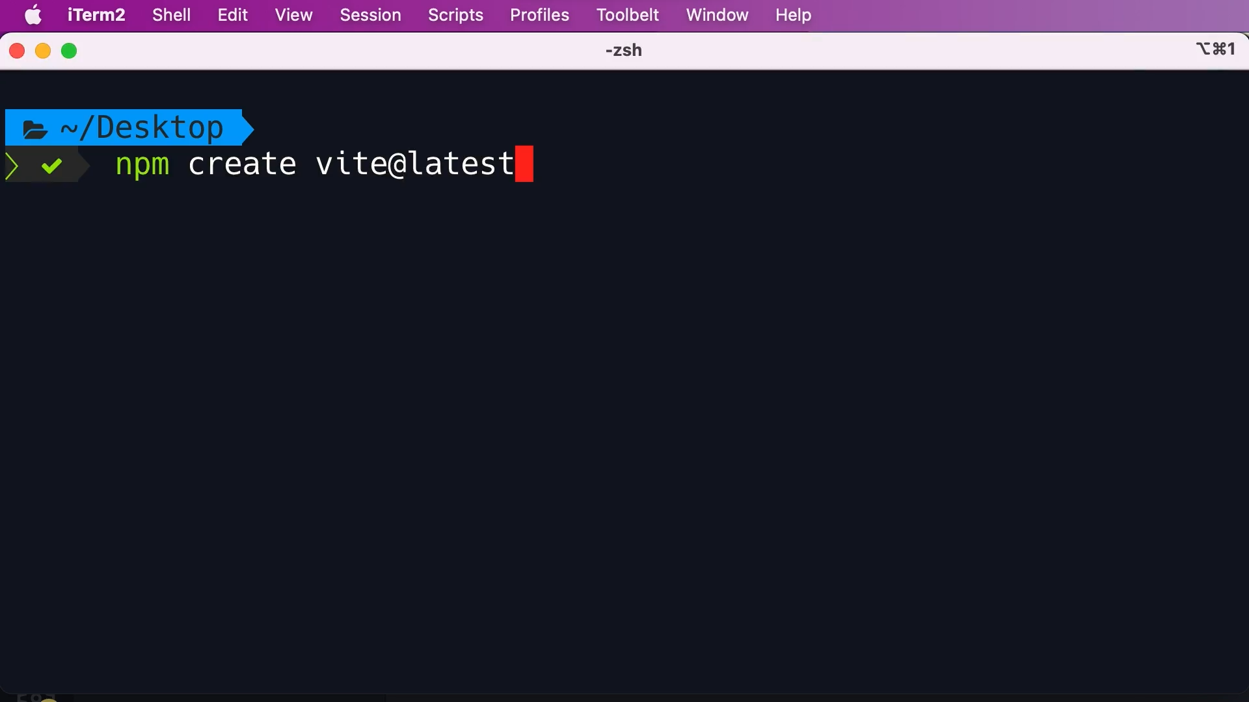

**Running application:**

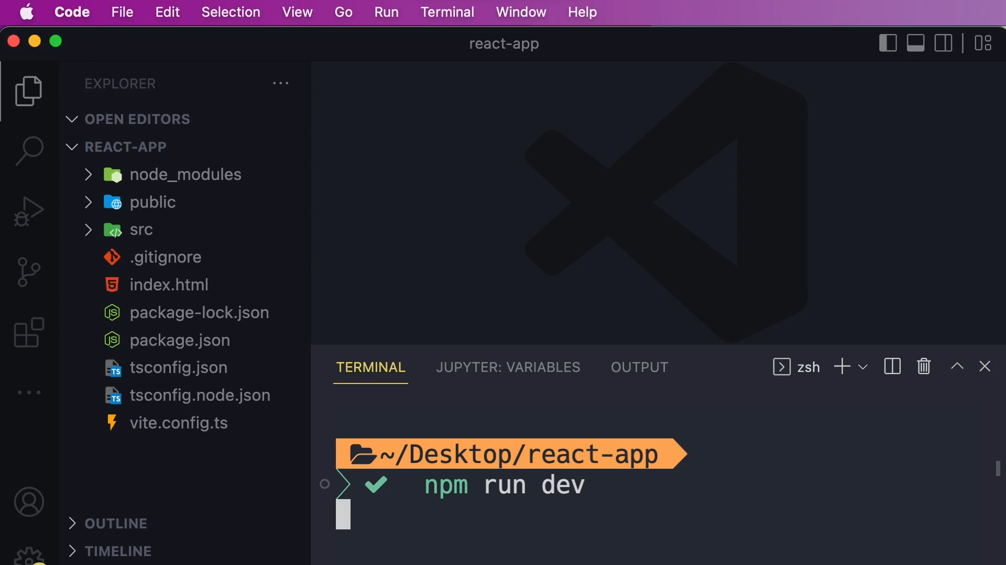

**React DOM:**

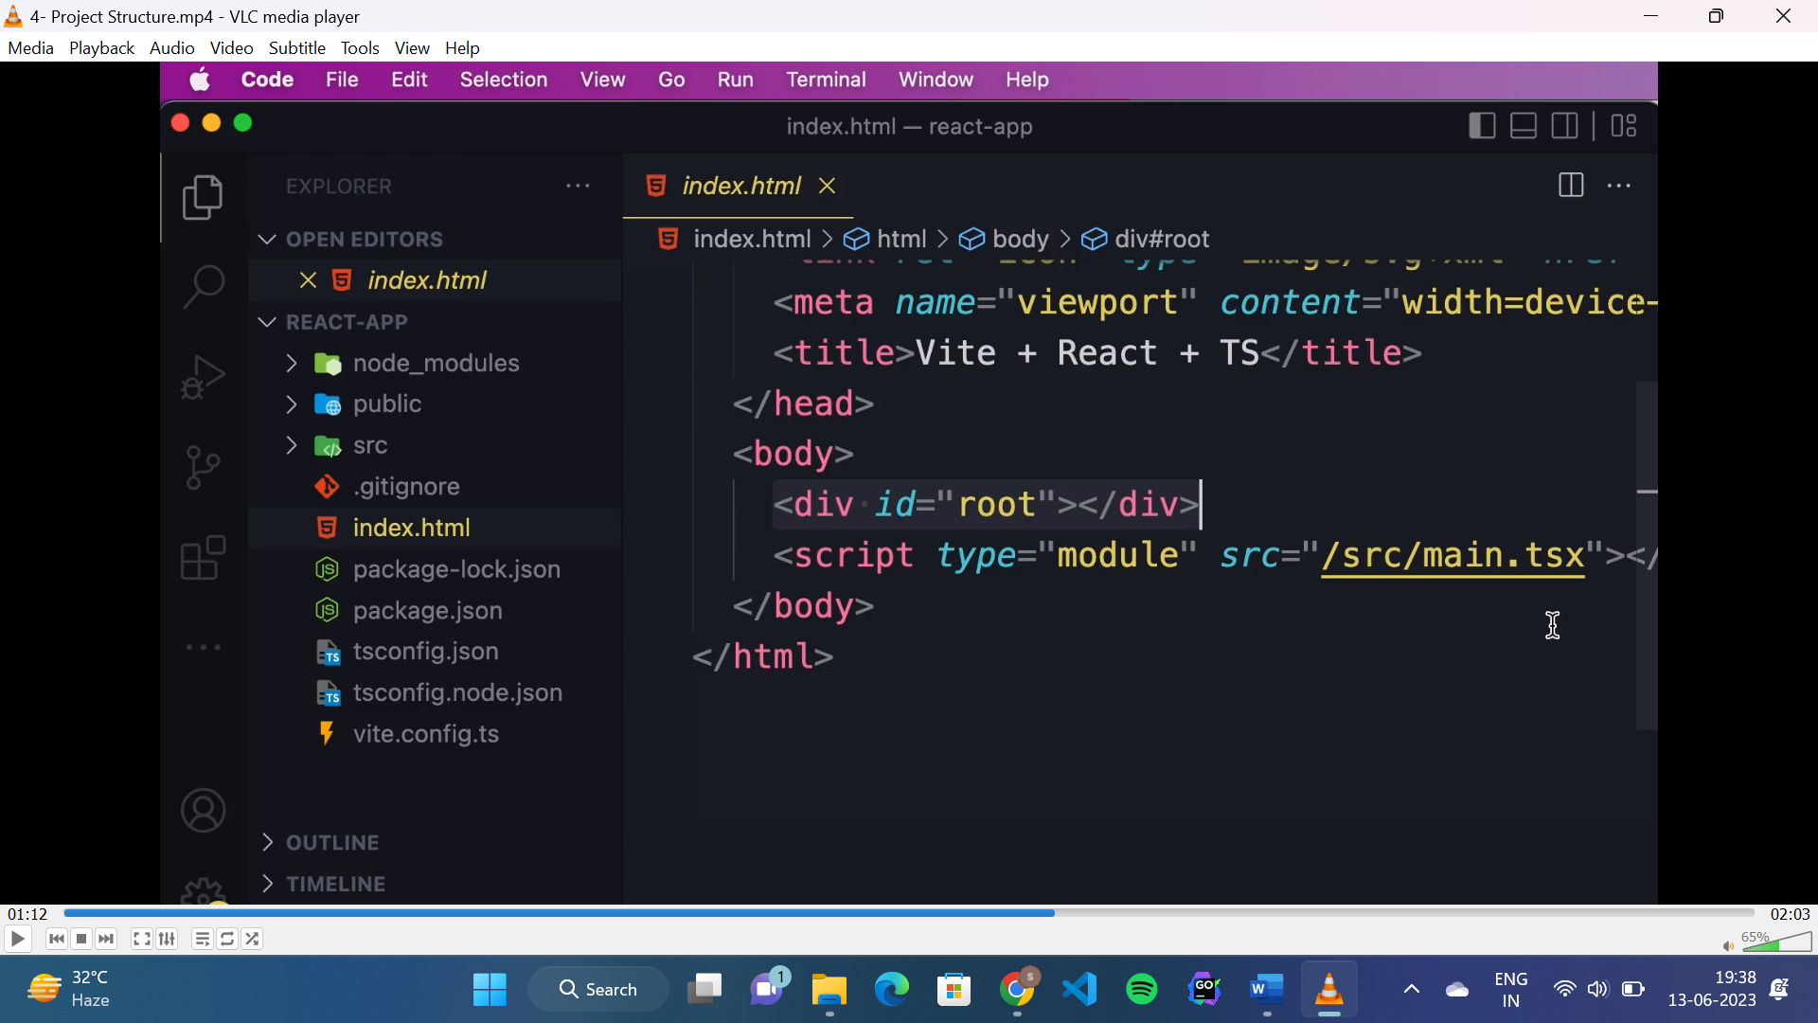

* “id=”root”” is the react container.
* “main.tsx” is the entry point of the application.

**React component:**

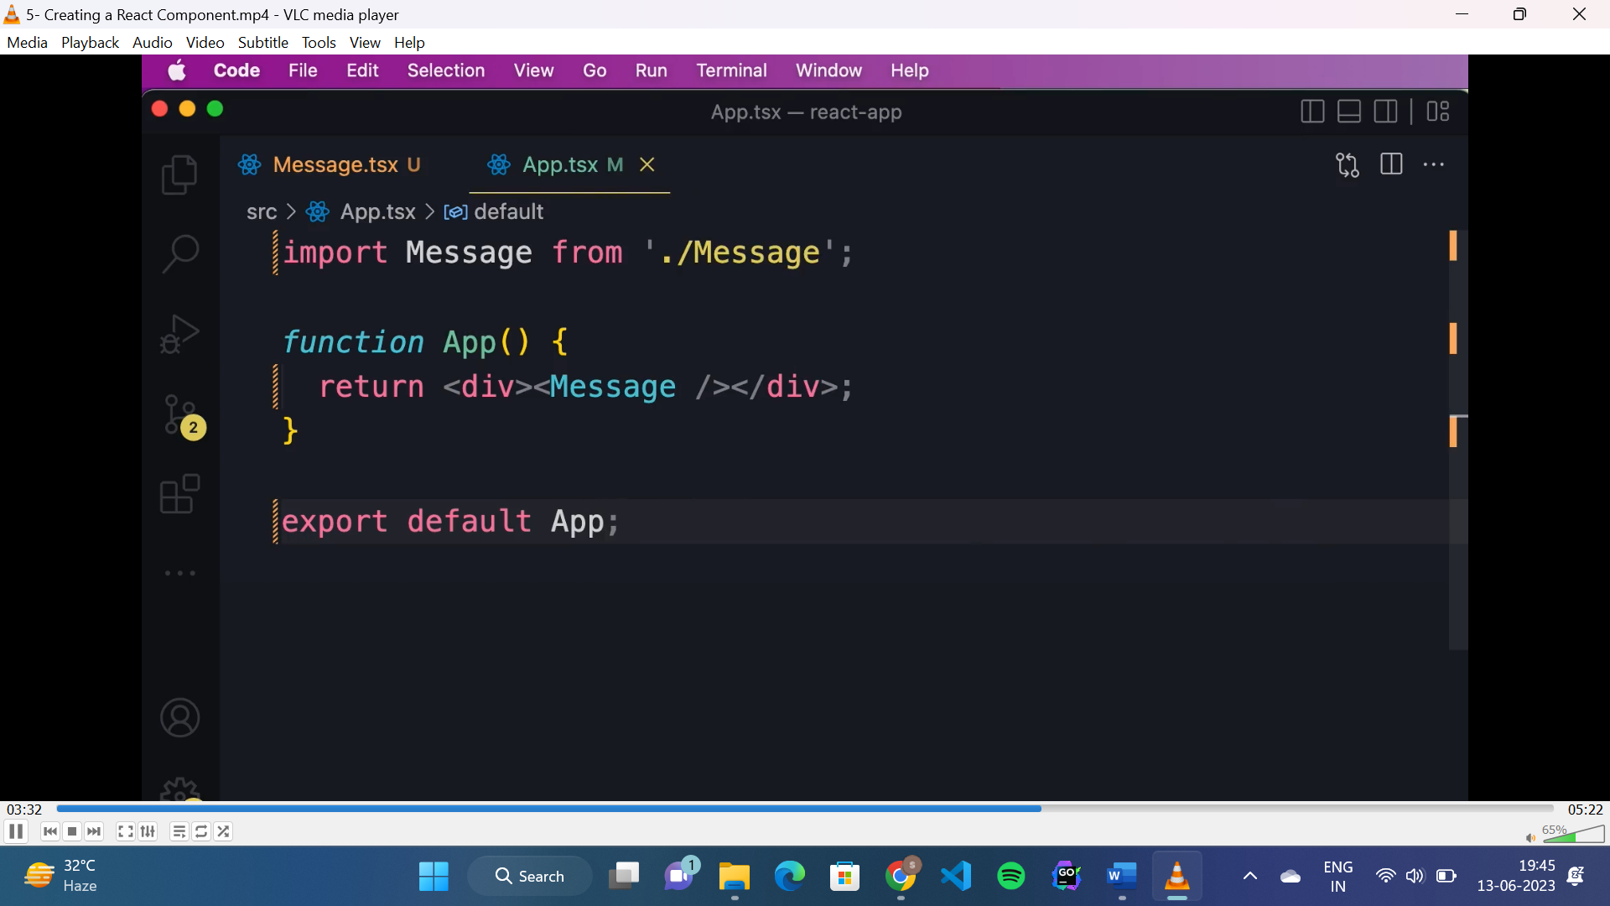

**Virtual DOM:**

* When we run application react takes the component tree structure of our application and creates JavaScript data structure called virtual DOM.
* It is light weight in memory representation of component tree.
* Here each node represents a component and its properties.
* When the state or data of component changes, the corresponding node of that component updated in the virtual DOM to reflect the new state.
* Then it will compare the current version of virtual DOM with the previous one and update those node which got changed.
* And this updating task in real DOM is done by “react DOM” library not by react.

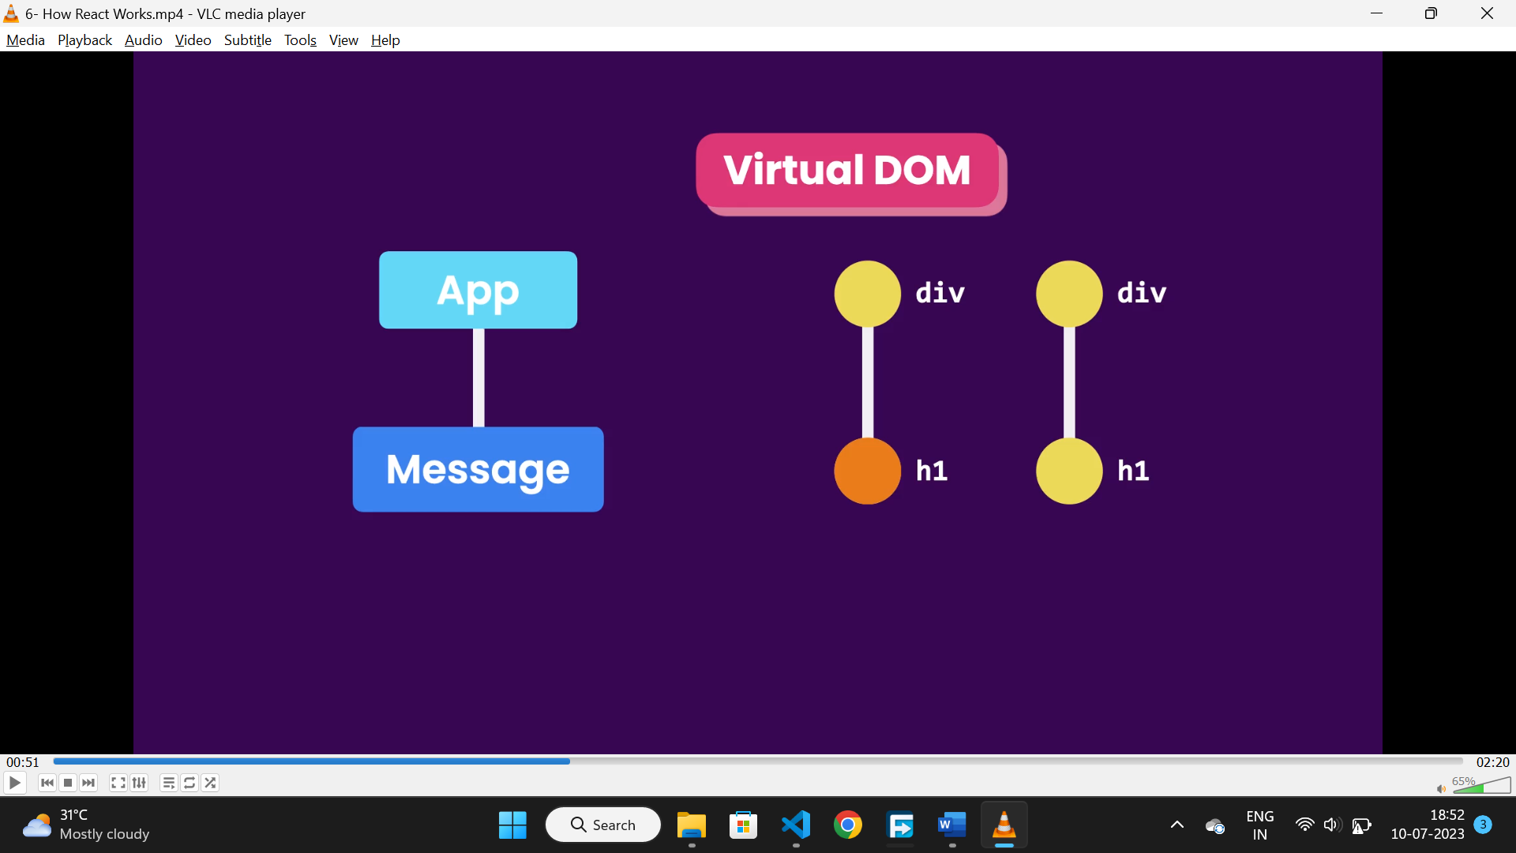

**React strict mode:**

* It is used to identify potential problems in react app.

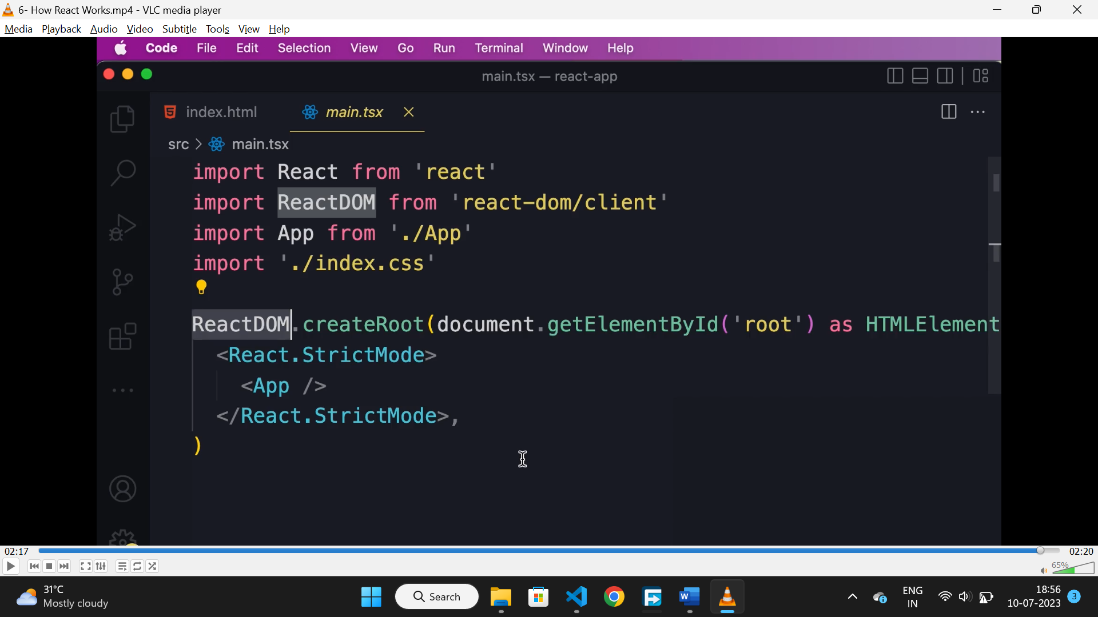

**Fragments:**

* Used to return multiple elements at a time.

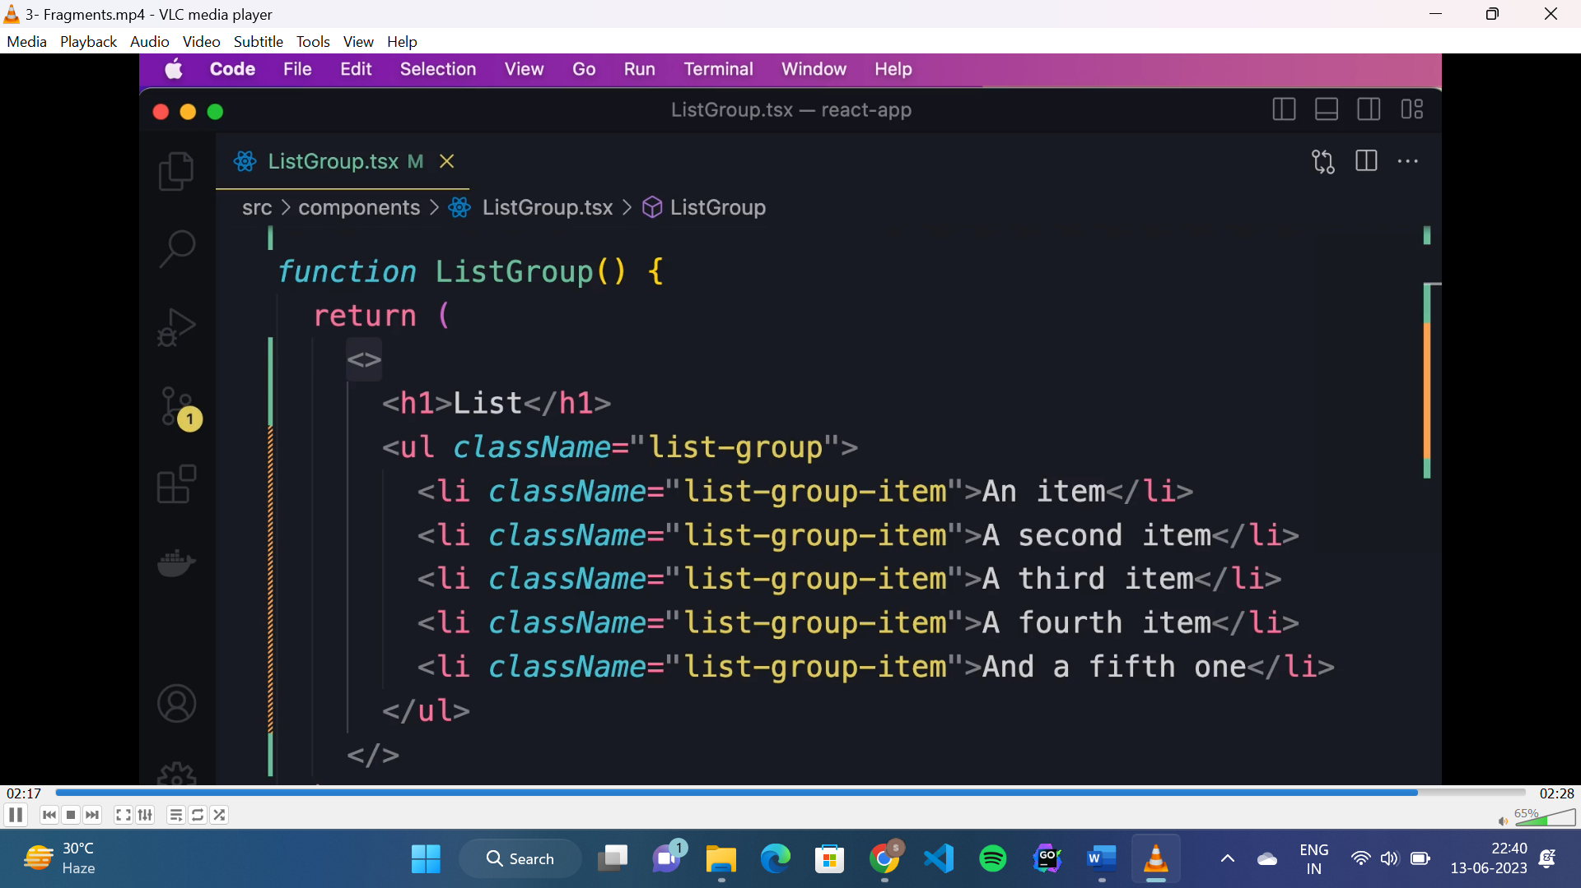

**Rendering list dynamically:**

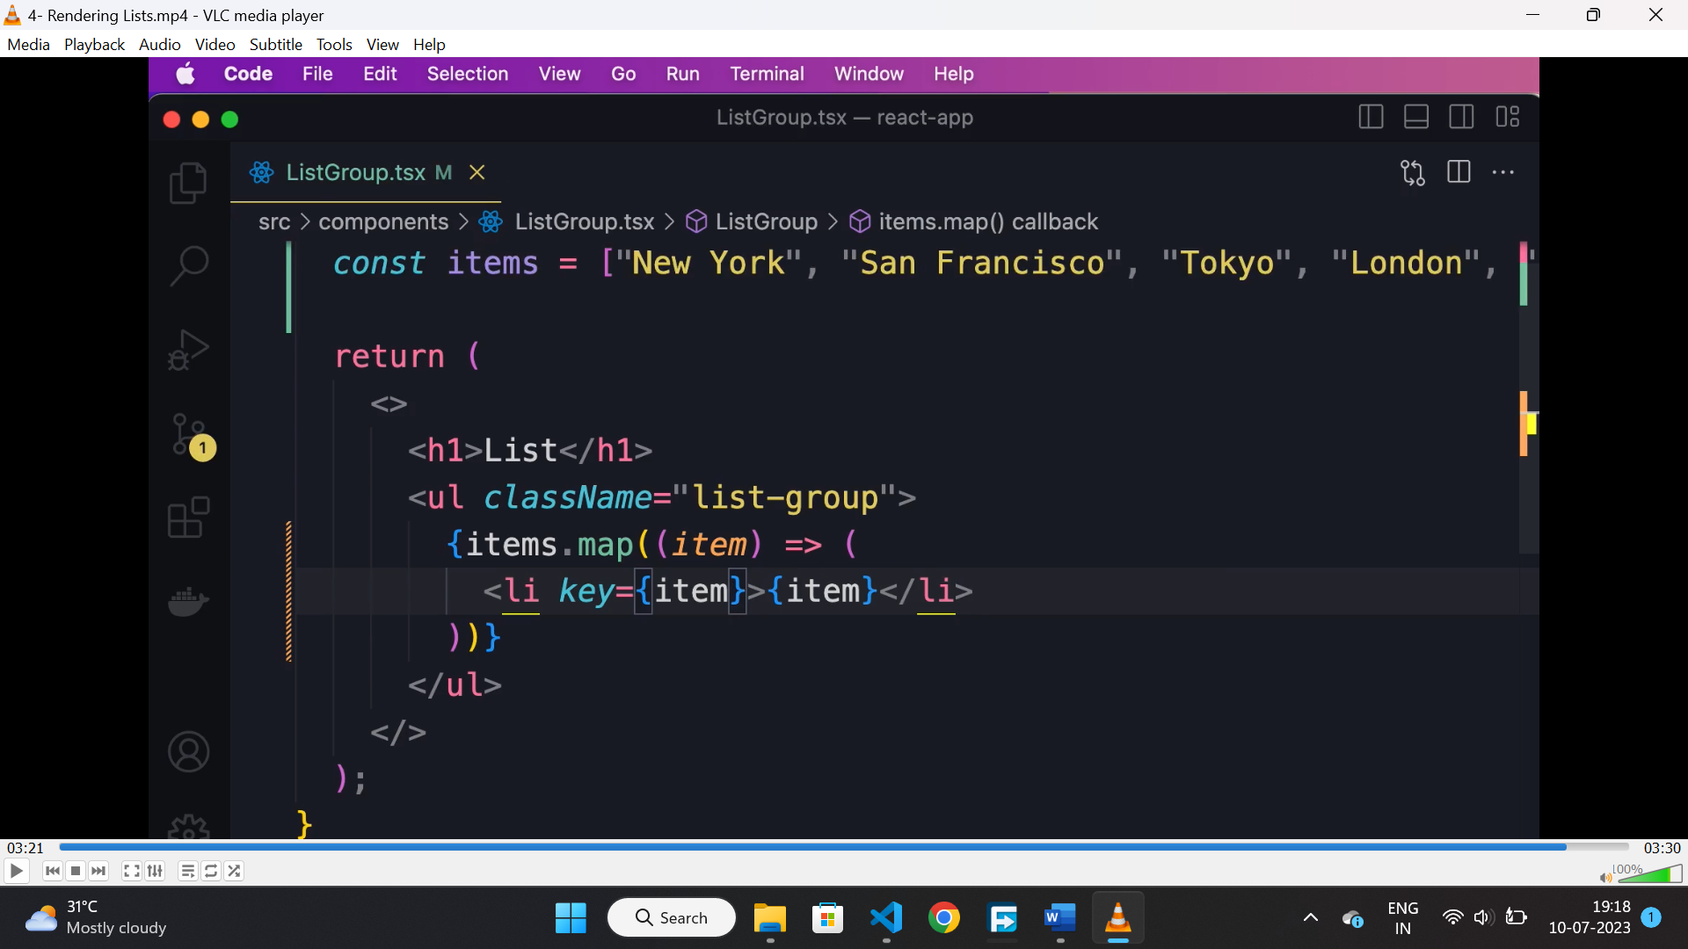

**Conditional rendering:**

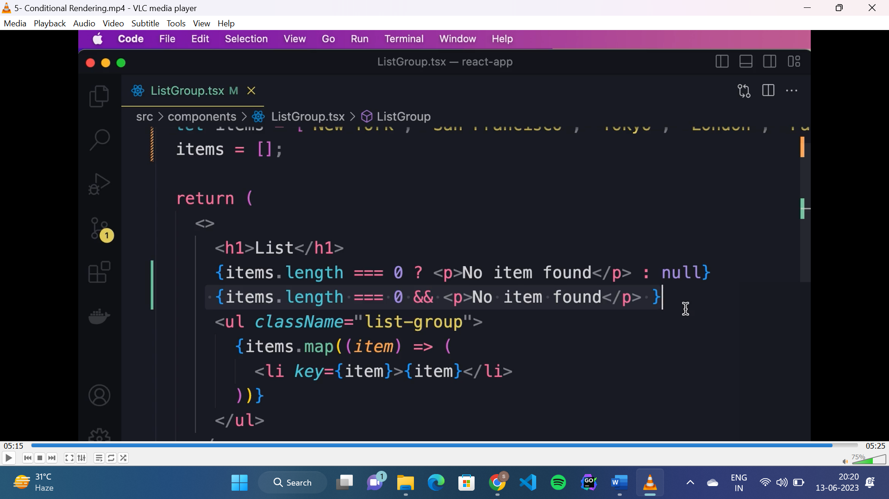

**Synthetic event:**

* It is a built in class in react because different browsers have different implementation of event object, so to make it cross browser, react made this wrapper over the browser event object.

**Handling event(TS):**

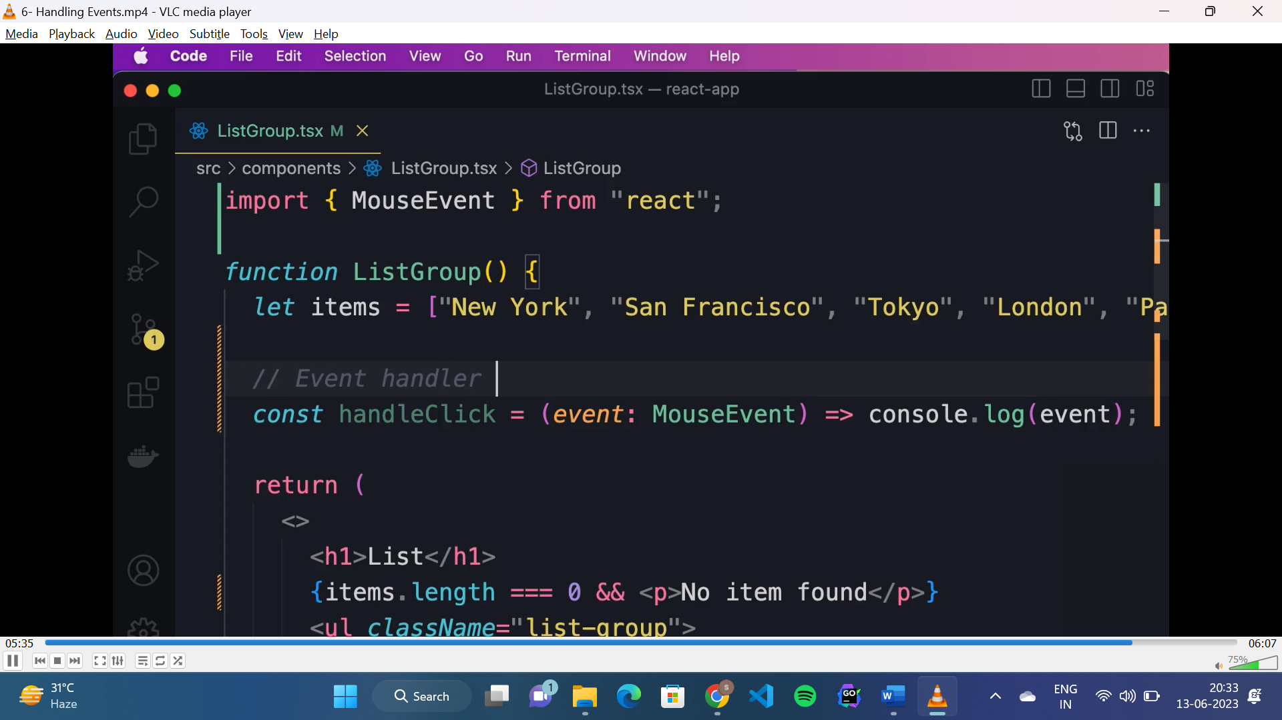

* To handle any mouse event, we need to define the event type as “event: MouseEvent”.

**Dynamically applying “active” class:**

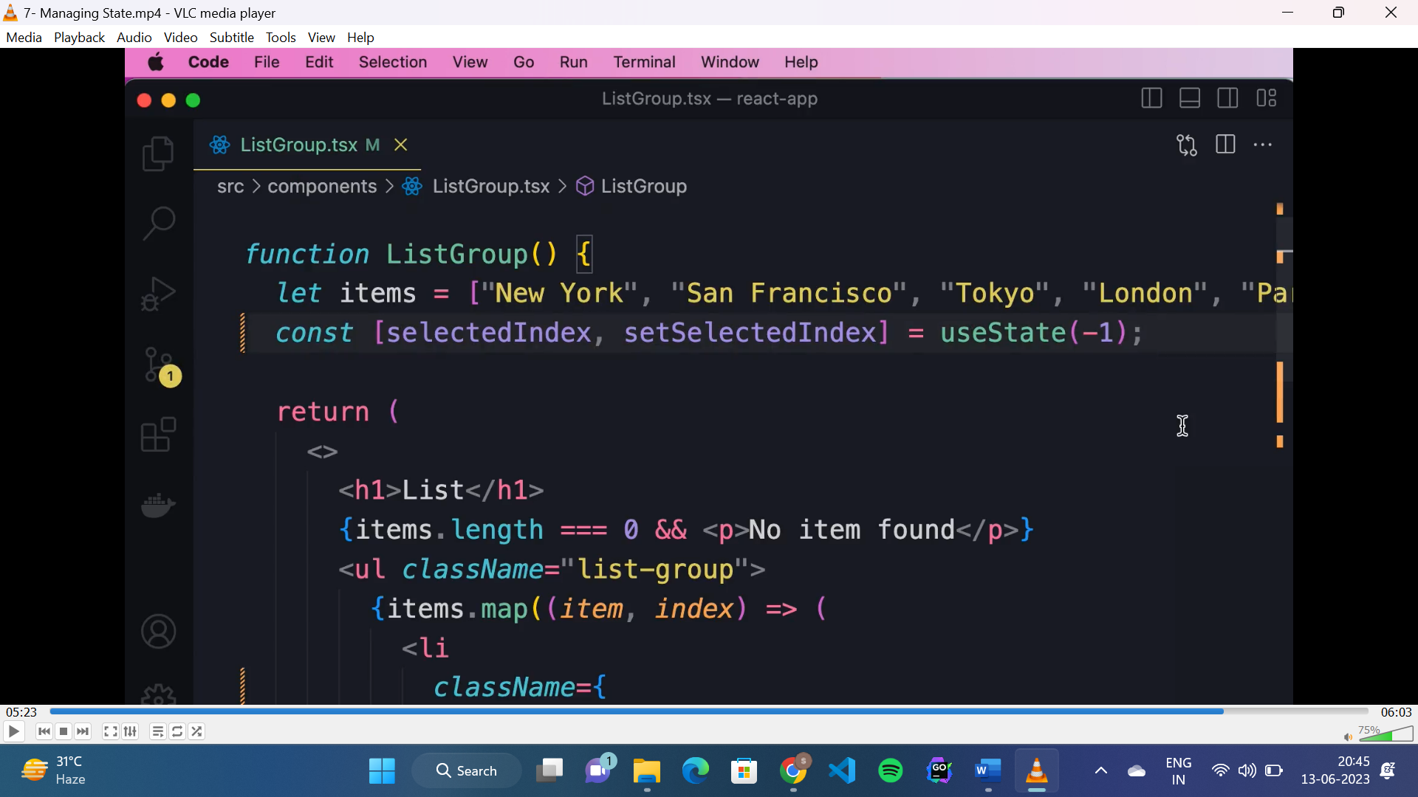

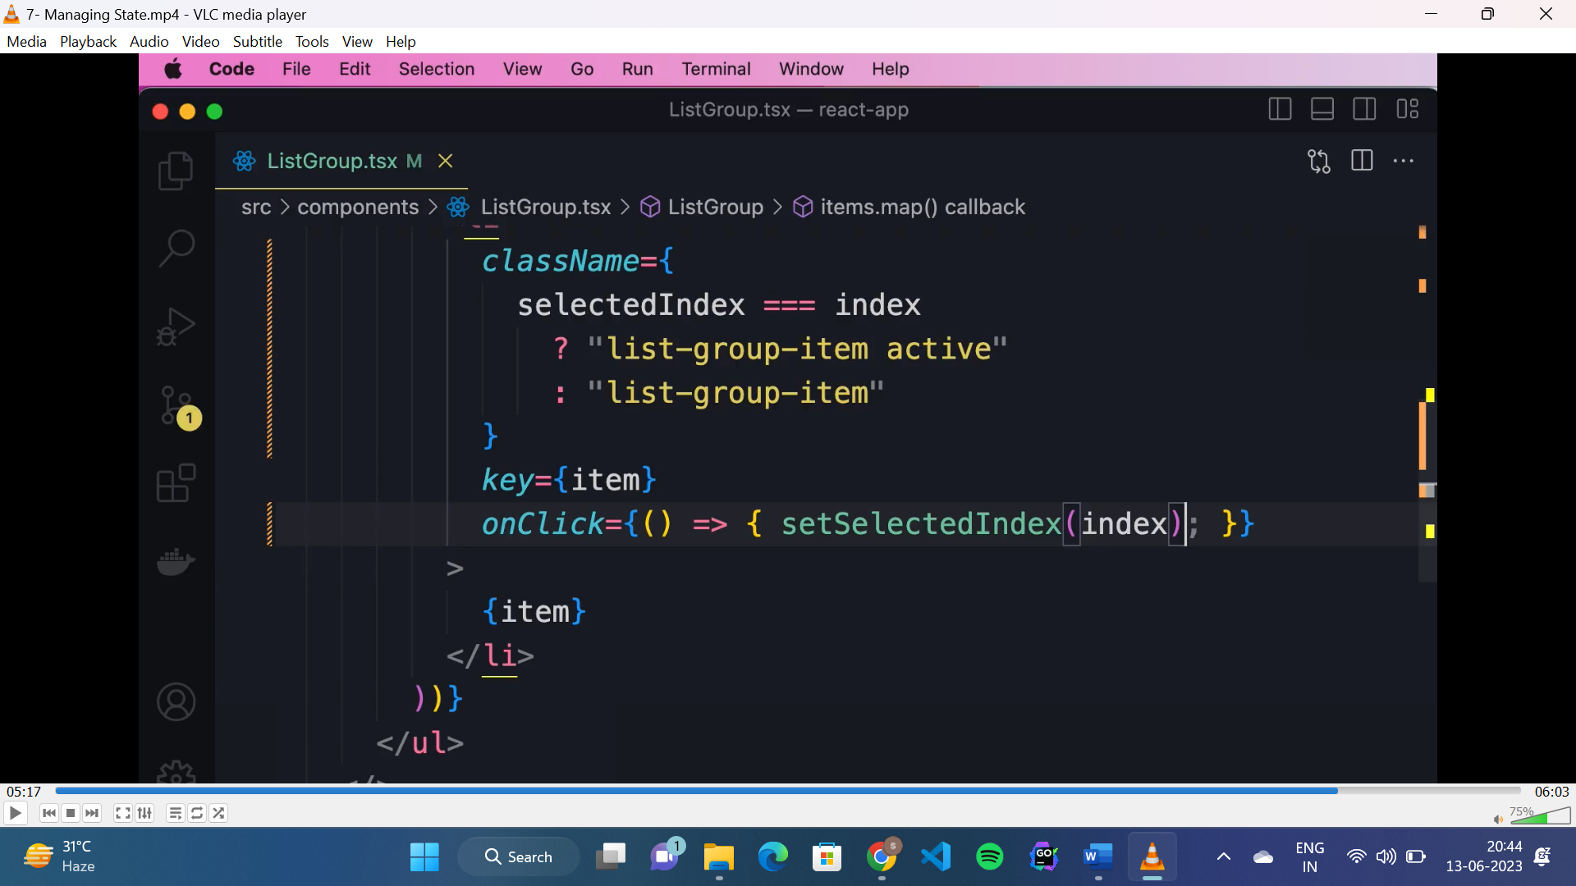

**TS interfaces:**

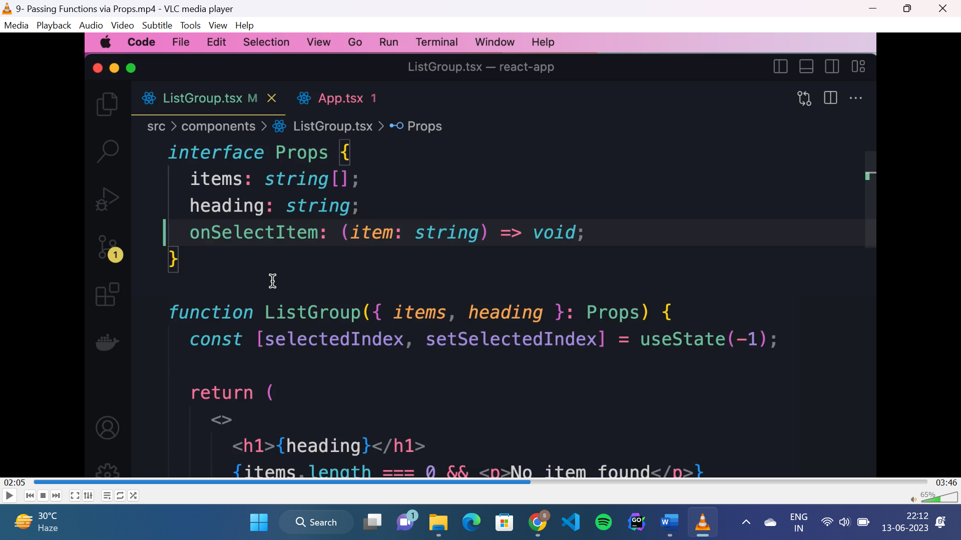

* Interfaces are used to define the shape of the input values(props) passed to a component.
* Starts with capital letter.

**Children prop:**

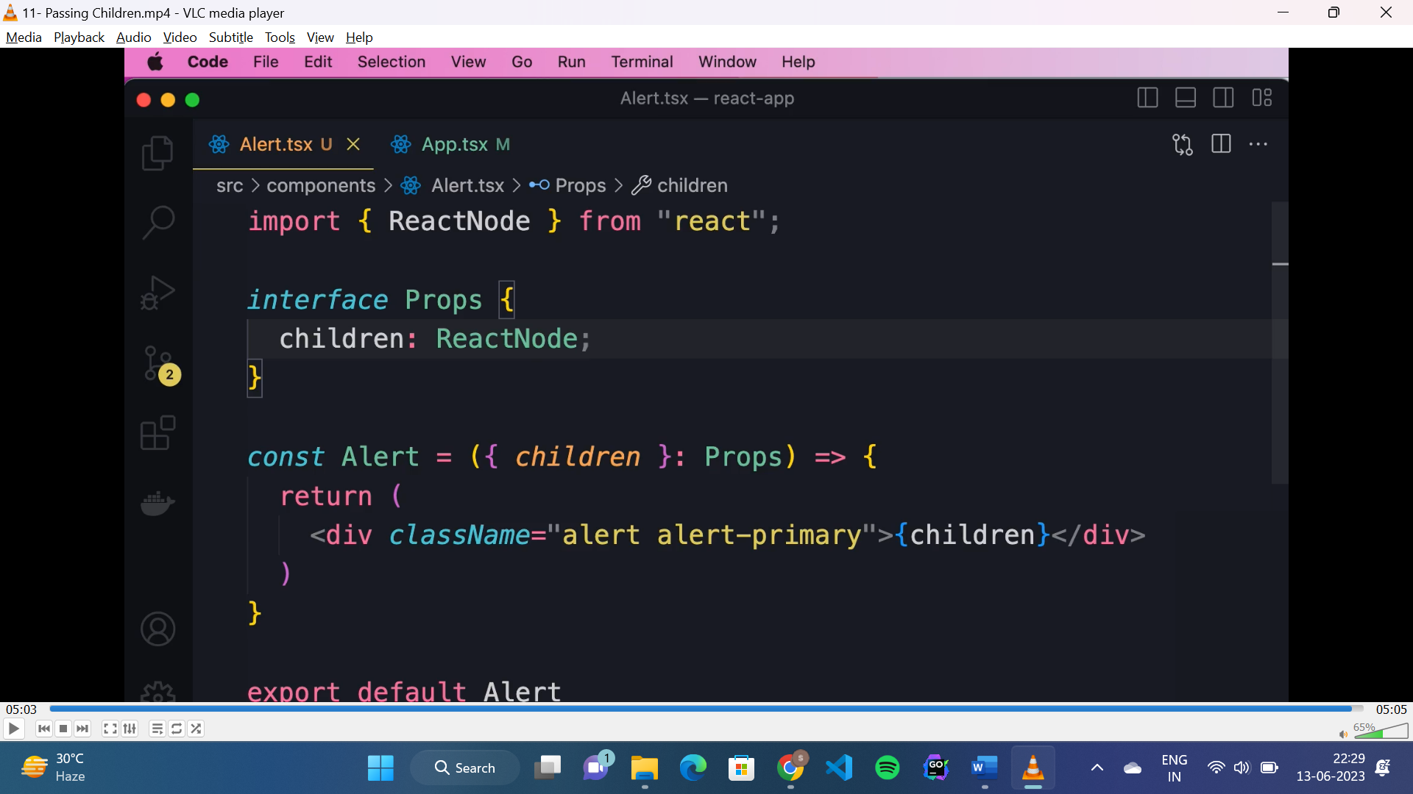

* To pass children as prop to a component:
* If it is a text: “children: string”
* If it is a HTML: “children: ReactNode”

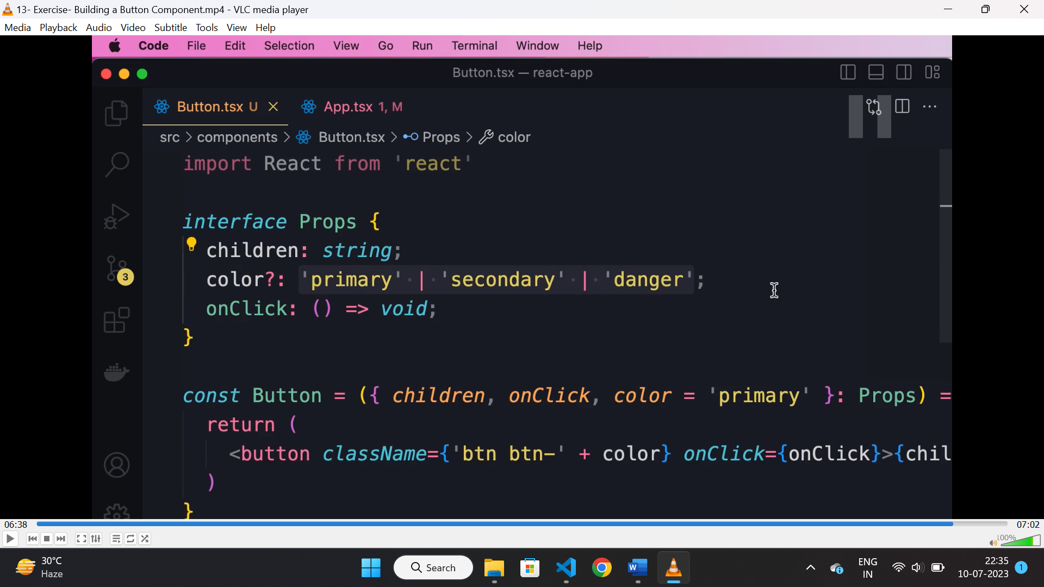

* In above interface “color” is a optional prop, and the value should be any of the values given.

**Props vs state:**

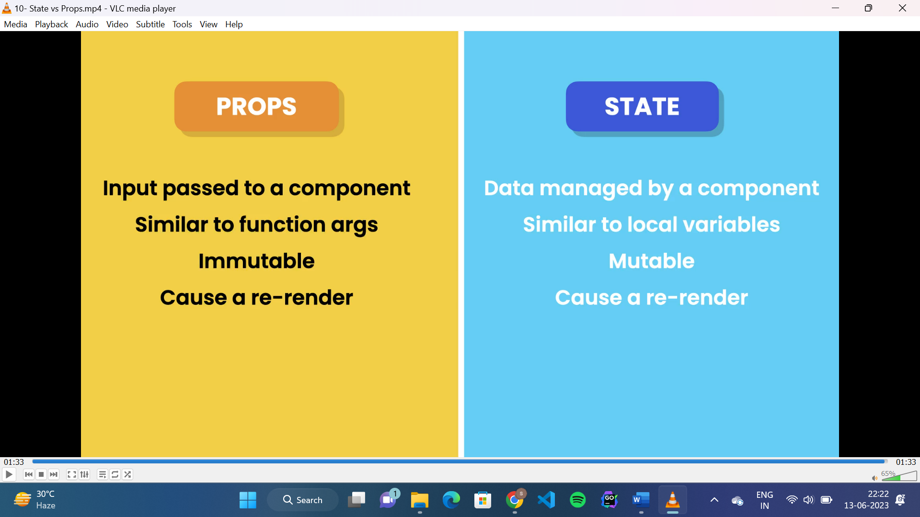

**Styled component:**

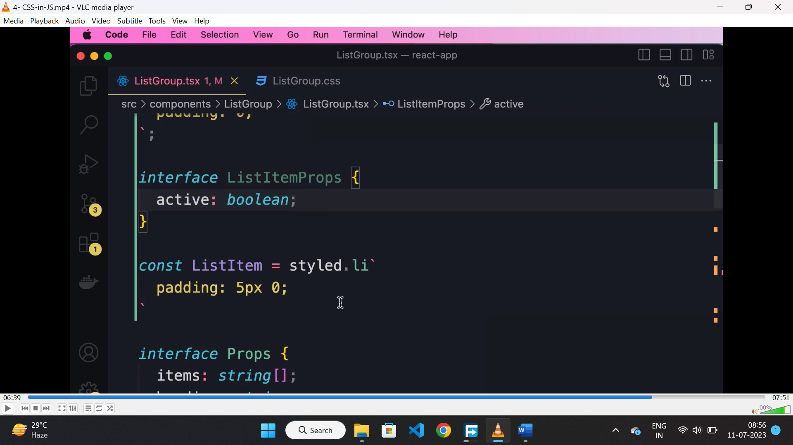

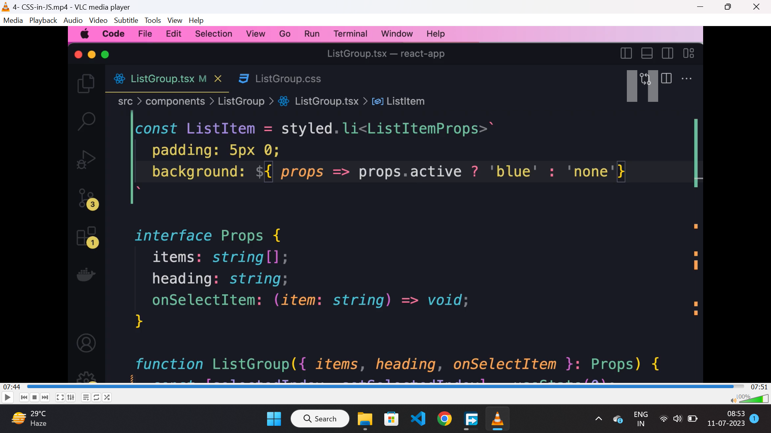

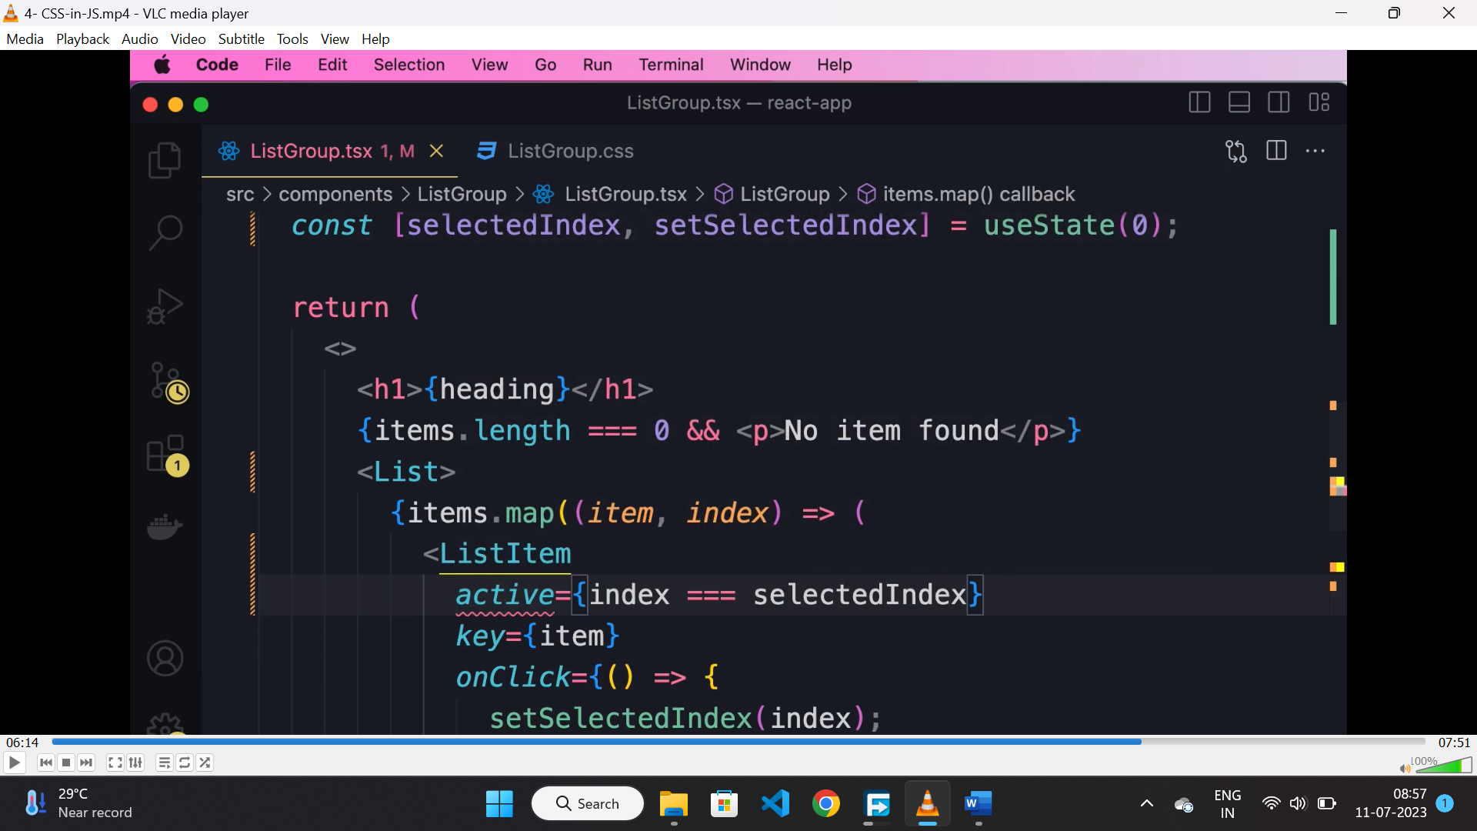

* It is a object which has all the html tags, using backtick we can define style for that HTML element and it will return a react component.
* We can also pass props to styled component.

**Inline style:**

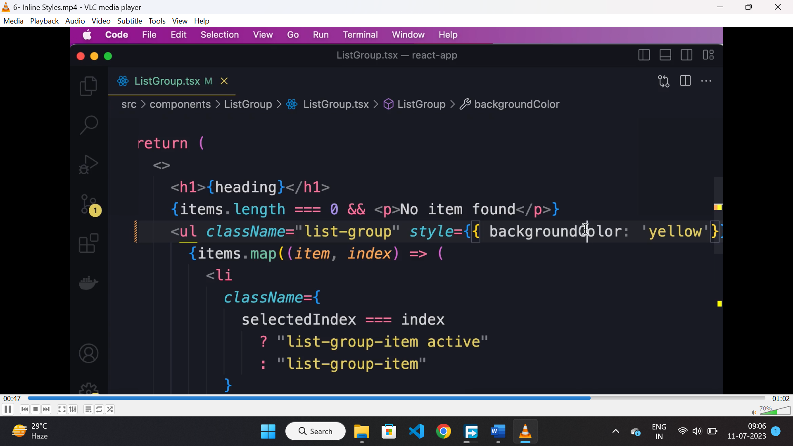

* We can apply inline style using the “style” attribute.
* The css properties should be mentioned in camel case notation here.

**React state:**

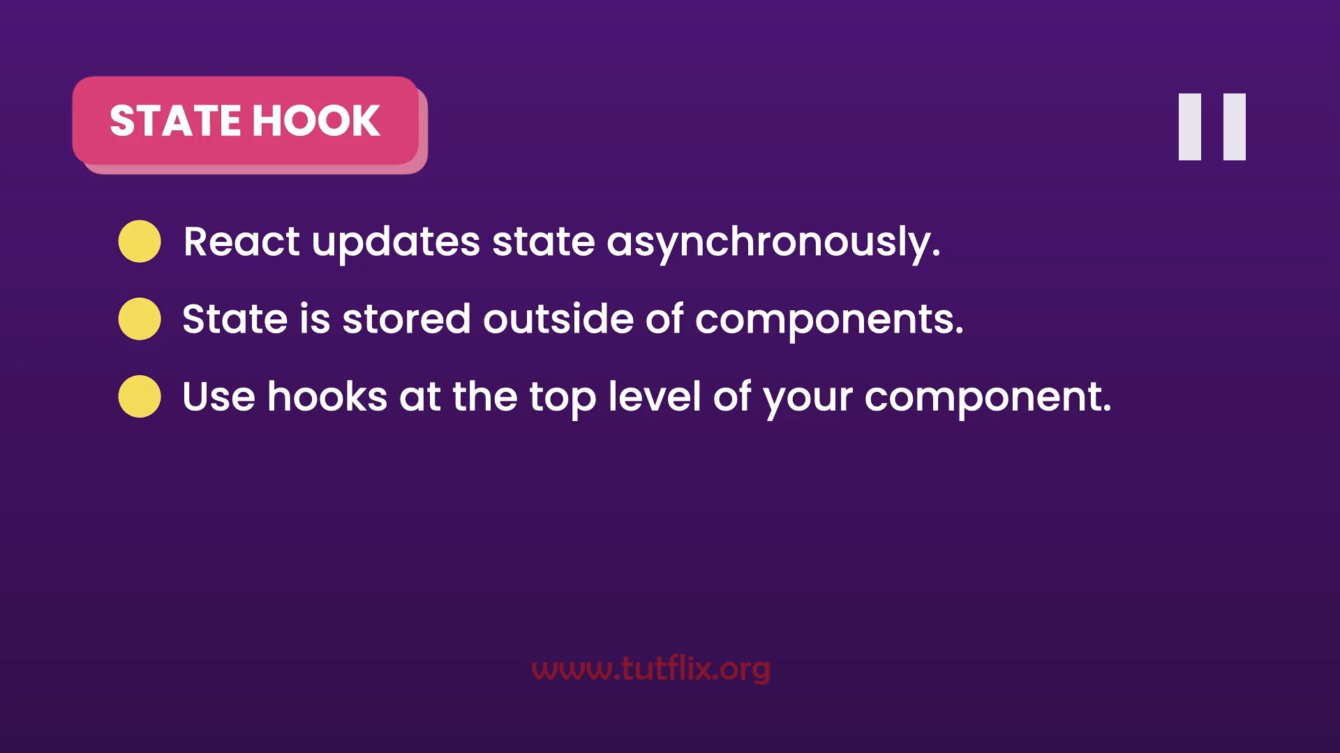

**Pure component:**

* If a component renders the same output for the same state and props then it is a pure function.
* React uses pure function for performance optimization, means if the props of the component didn’t change then it will avoid unnecessary rerenders.

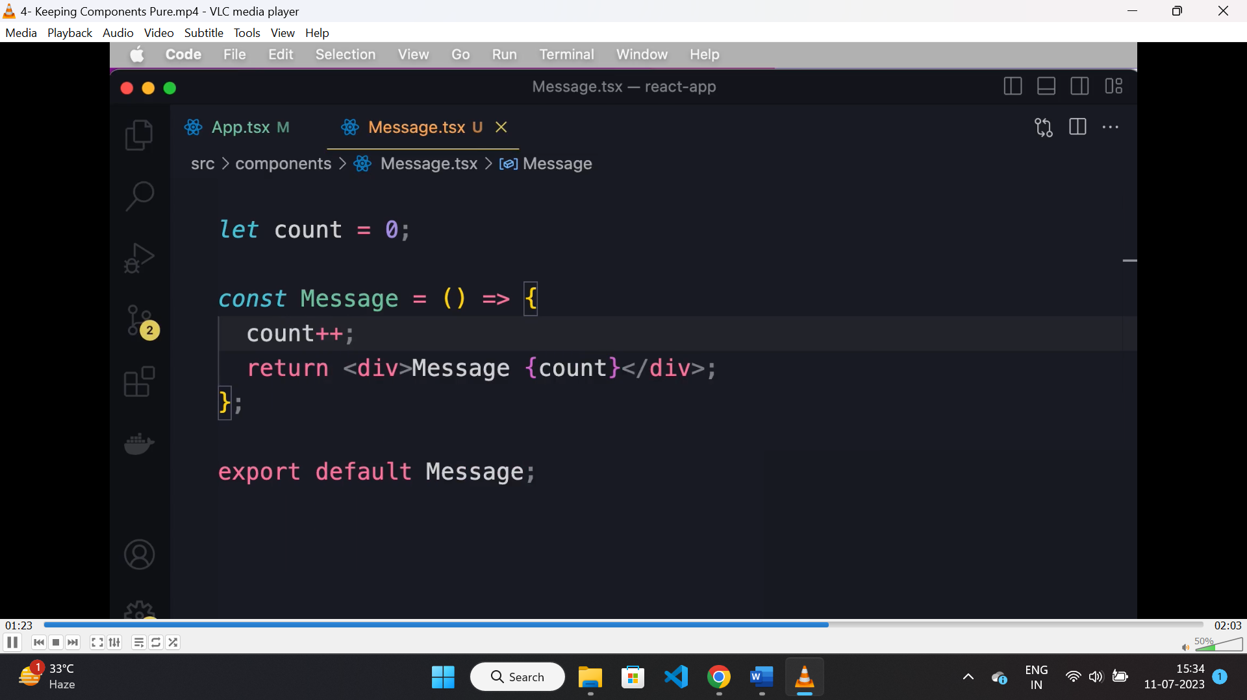

* Above is the example of “impure” function, coz the value of count changes on every render of this component.

**Useref:**

* It is used for referencing a DOM element and read its value when form is submitted.
* “useRef” returns a reference object.

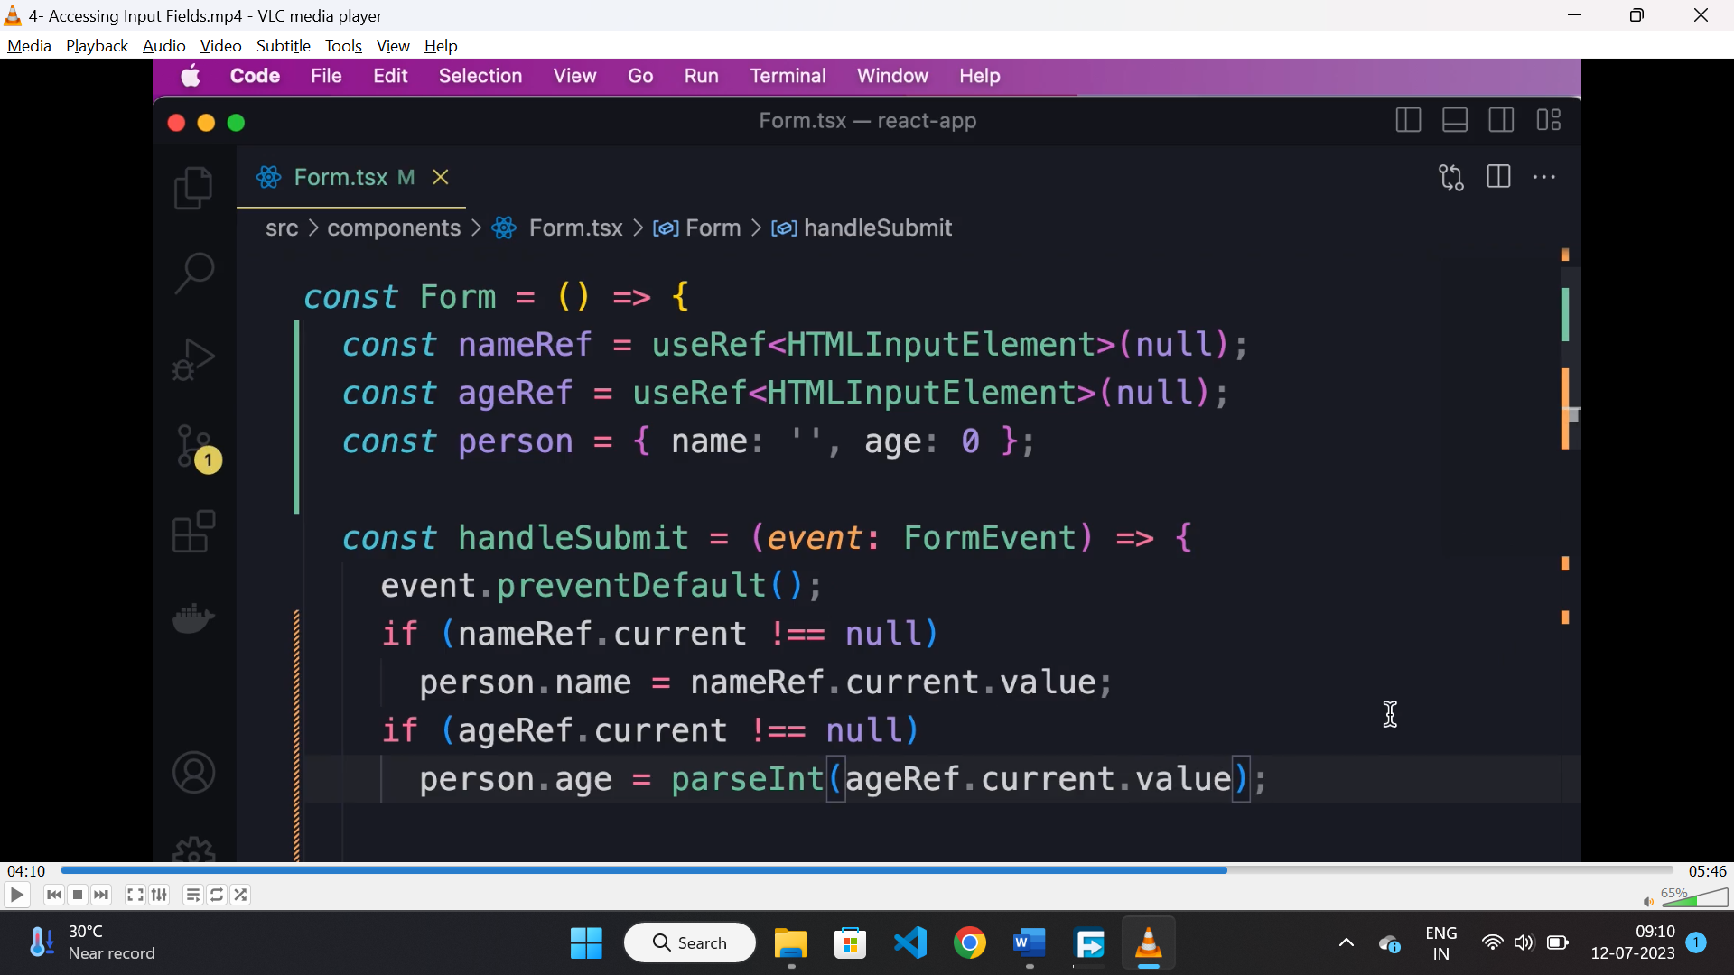

**Controlled component:**

* If the value of the html element is entirely controlled by state and not by DOM then it is a controlled component.

**React hook form:**

* It is a library that helps to manage complex form in ease, it is lightweight and high performance.
* To use it we need to import useform hook and destructure register and handlesubmit out of it.
* Handlesubmit will be called when form is submitted.

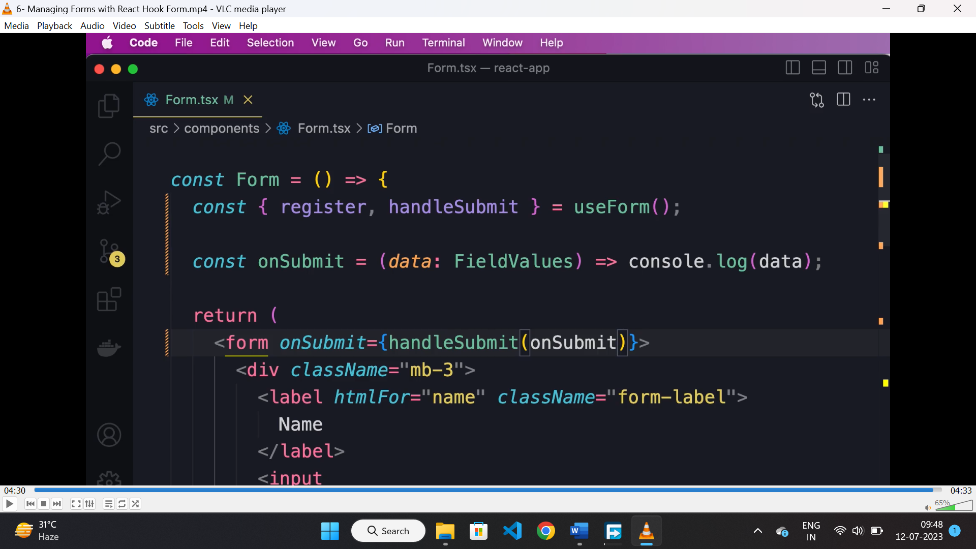

* To register a html element, we need to call the register function passing the name of the field as parameter and it returns an object.

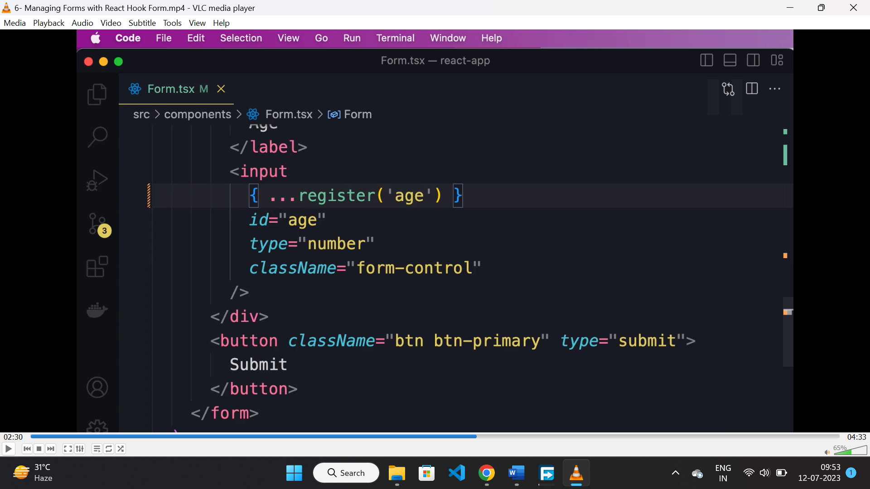

* By registering a element following property will be added to the HTML element.

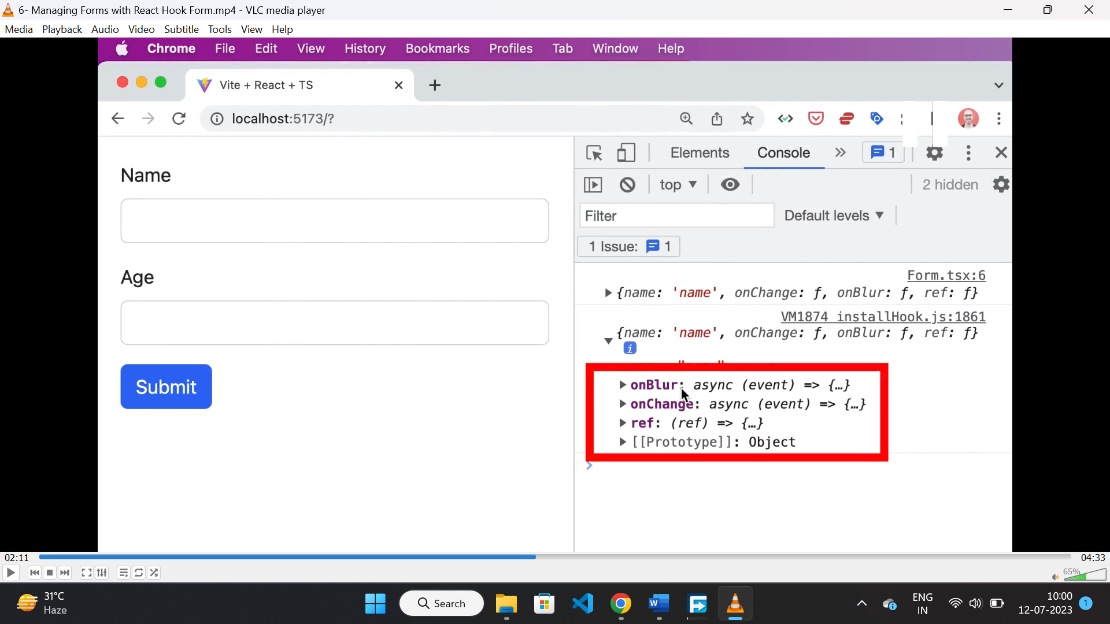

**Handling validation using form hook:**

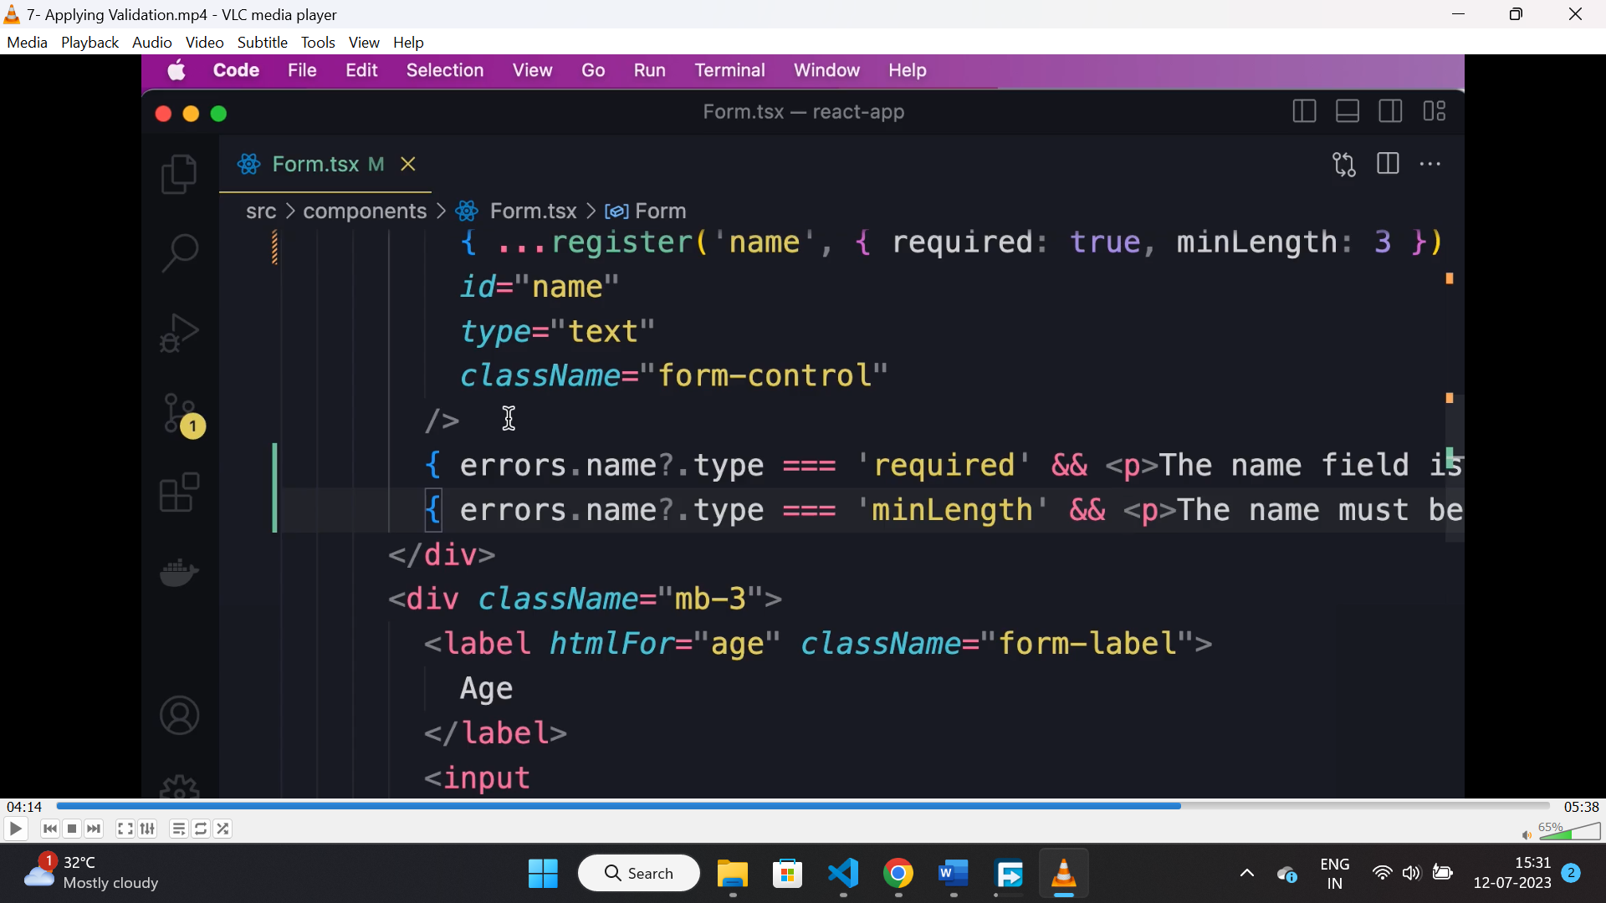

* Here in register function, we can pass a second parameter as a validation object. The properties are “required”, “min-length” and “max-length” etc.
* If the filed is failed to validate then, while submitting the form the “useForm” will kick in and we can destructre the formState from there and check for error form there.

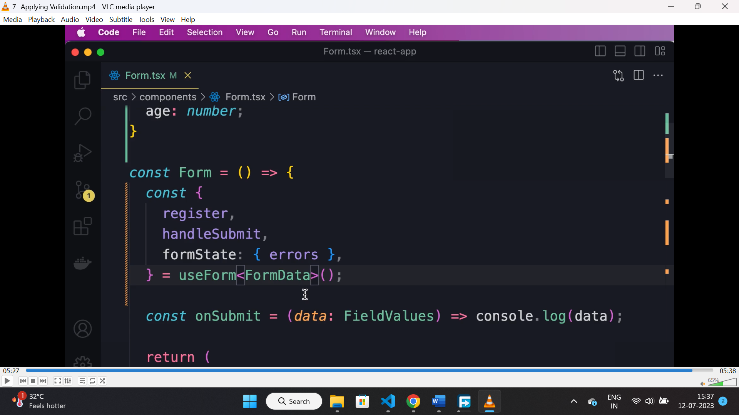

* Based on the validation error we can render errors below the filed.

**Validation with ZOD:**

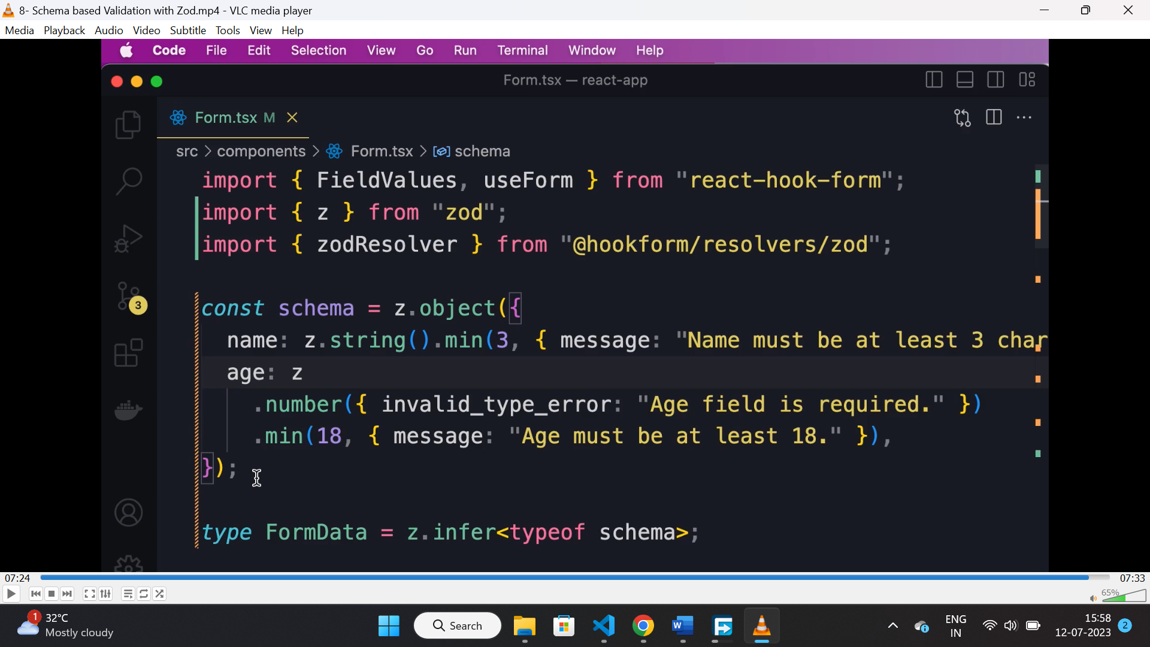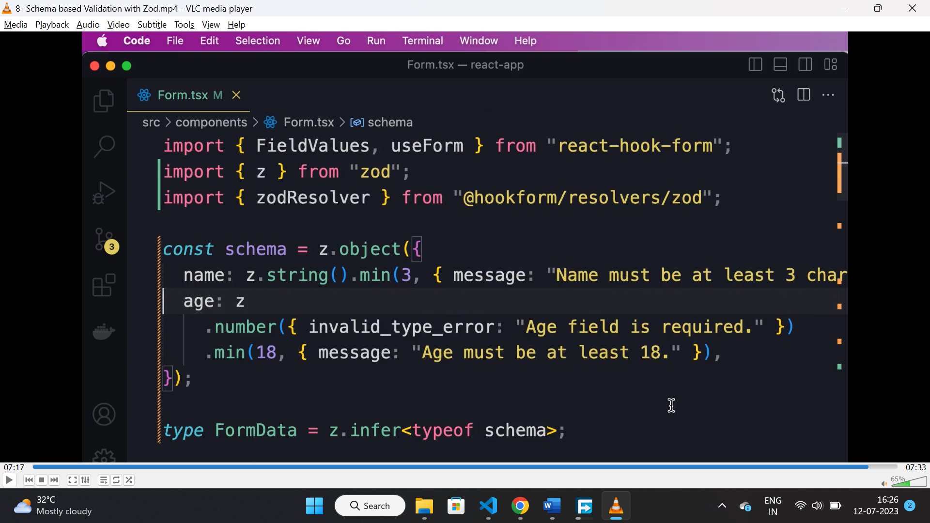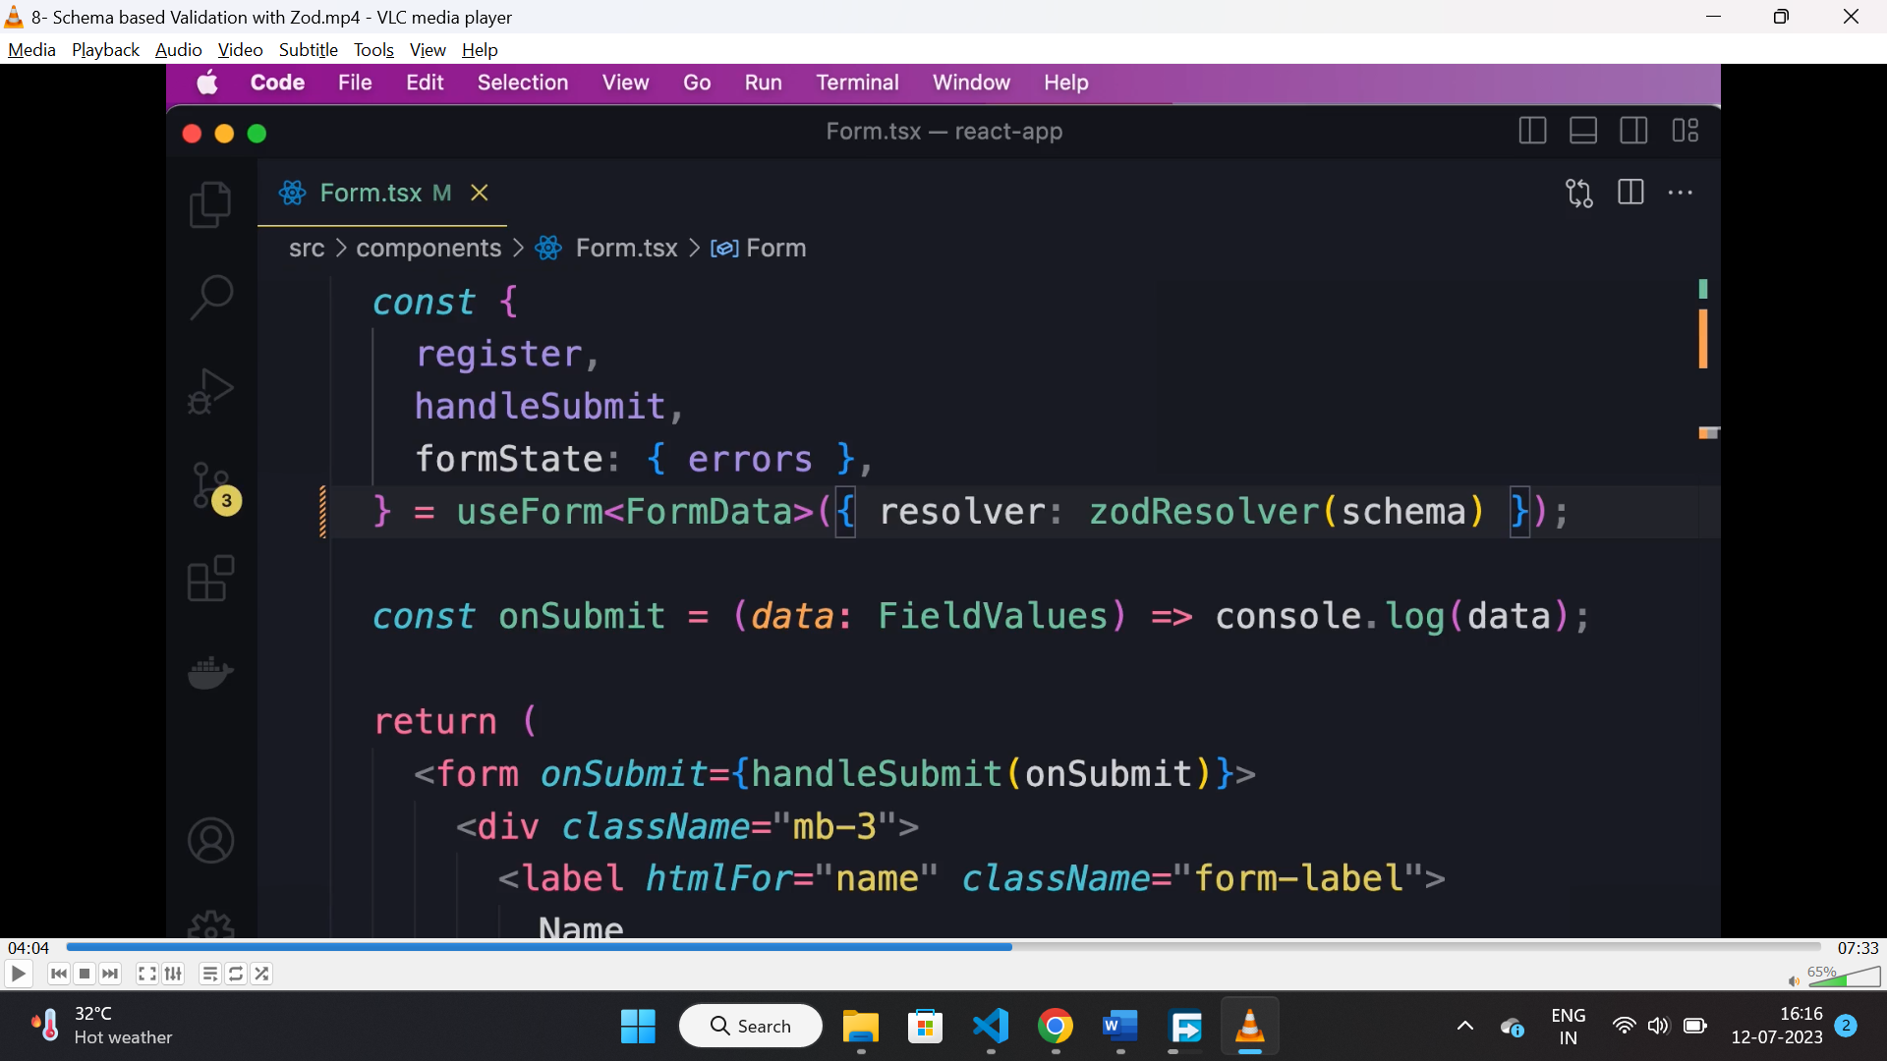

* Create a schema object using zod.
* Install “@hookform/resolver” for integrating zod with “hookform”.
* Pass “zodResolver” function as a resolver, with created schema as a parameter to it.
* While creating schema we can create custom error messages to it.

**useEffect hook:**

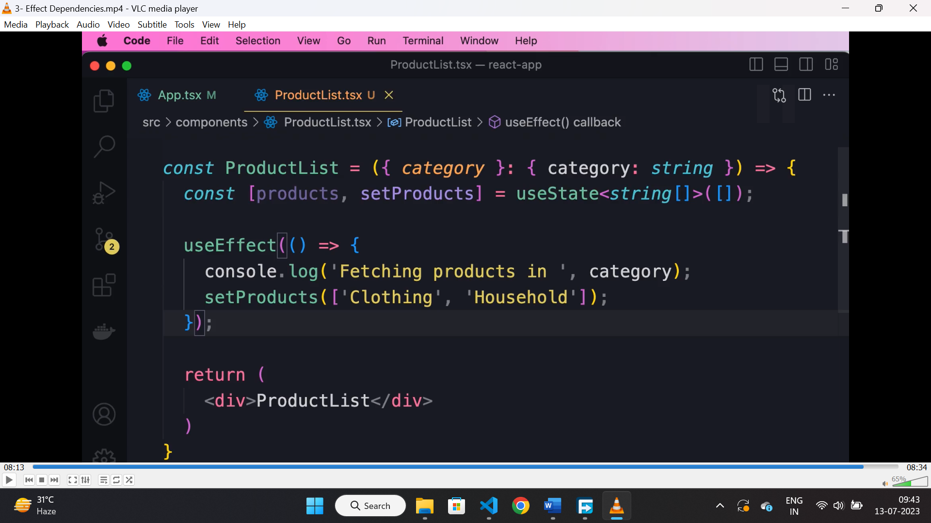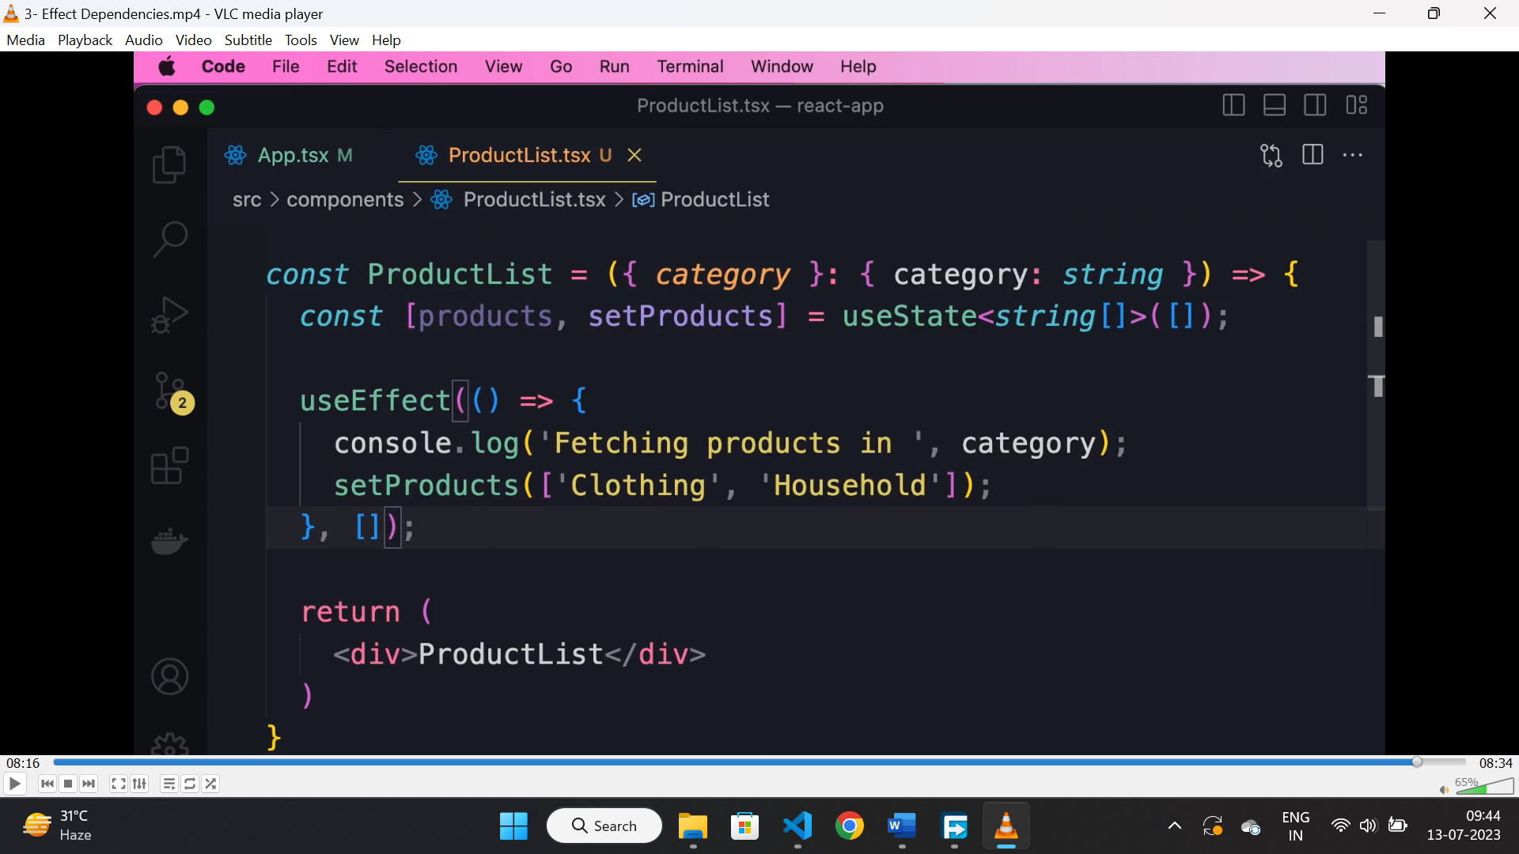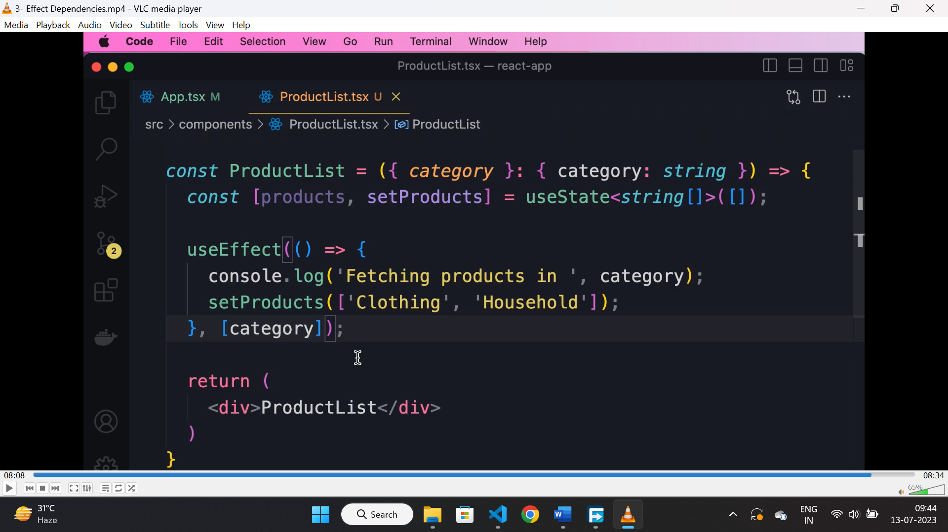

* If we are not passing any 2nd argument then “useEffect()” hook will run in first and on every render on state or props change.
* If we pass 2nd argument as empty array then it will run on 1st or initial render only.
* If we pass any value in 2nd parameter then “useEffect()” will run when there is a change in the dependency.

**useEffect as unmounting:**

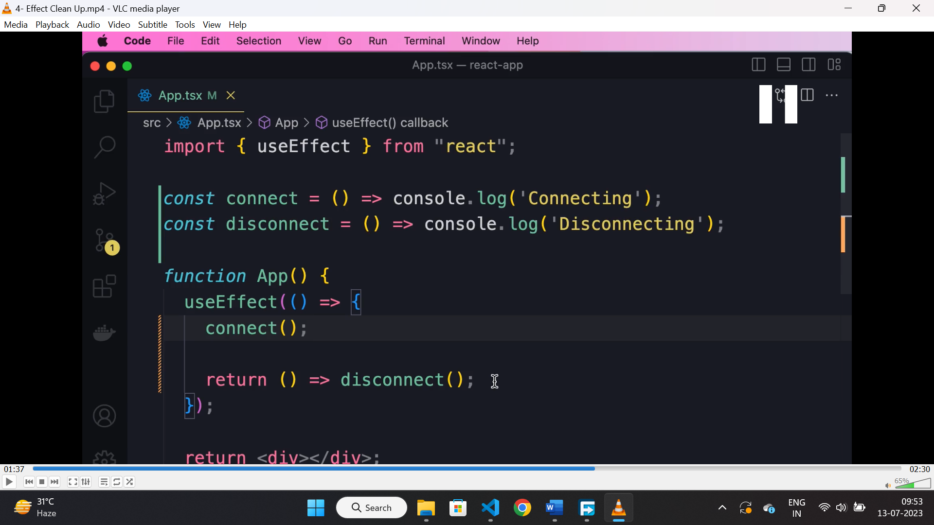

* “useEffect()” optionally returns a function which is used for cleanup.
* It is used for cancelling API calls, ignoring results from API, disconnection to server etc.

**Handling error with Async await:**

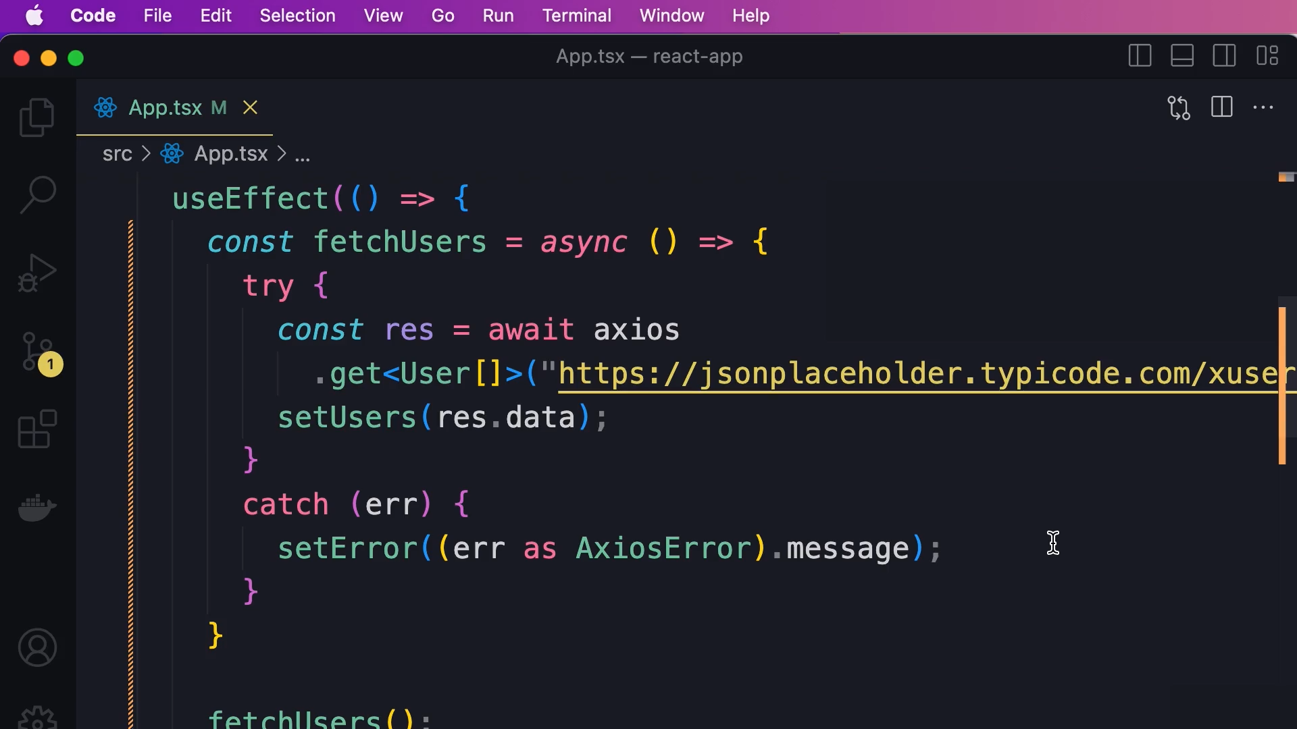

* With traditional promise method we can use “.then().catch()” method to handle data and error.
* With async and await we can use “try{}catch(err){}” for handling error.
* Traditional method is preferable.

**Cancelling a API call:**

* To cancel asynchronous operation, DOM manipulation or task that will take time, we can use “AbortController()” class.
* Then we can pass a second parameter to “axios.get()” set “signal” property of “controller.signal” there.
* Finally in the cleanup function we can call the abort() method of controller instance.

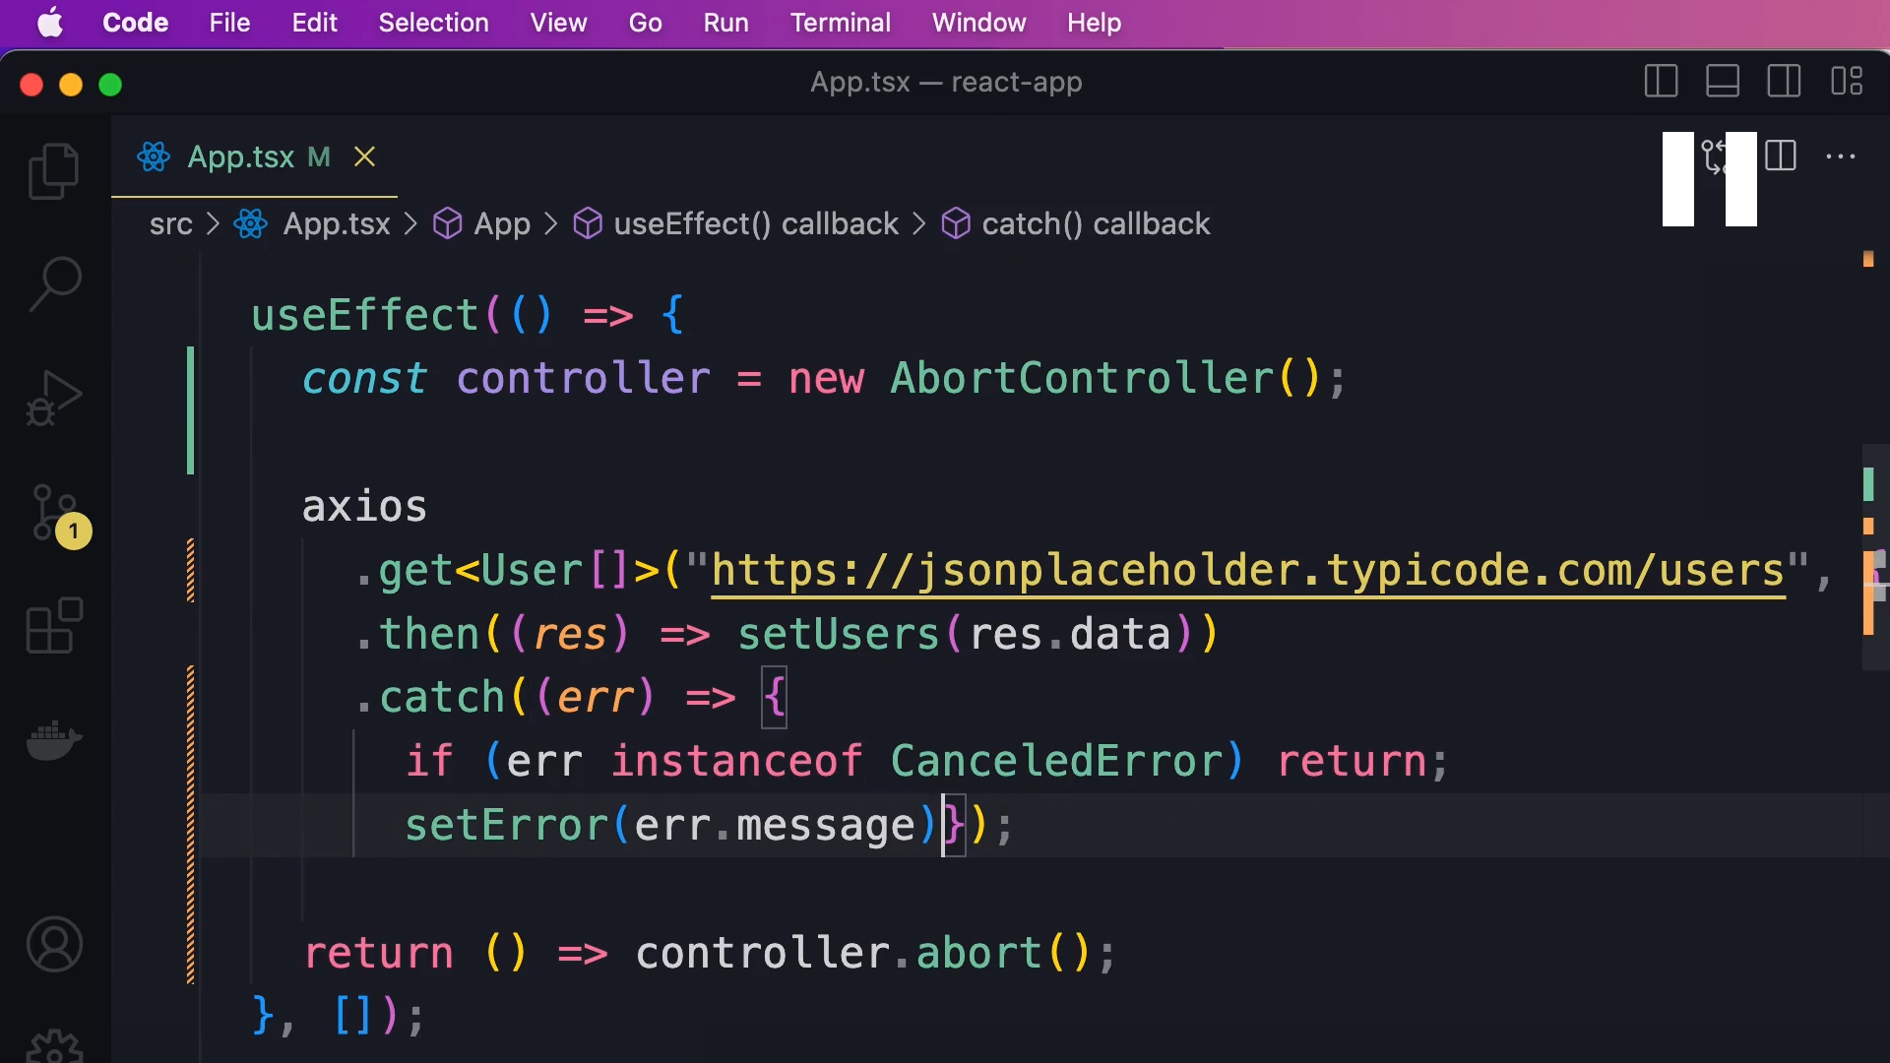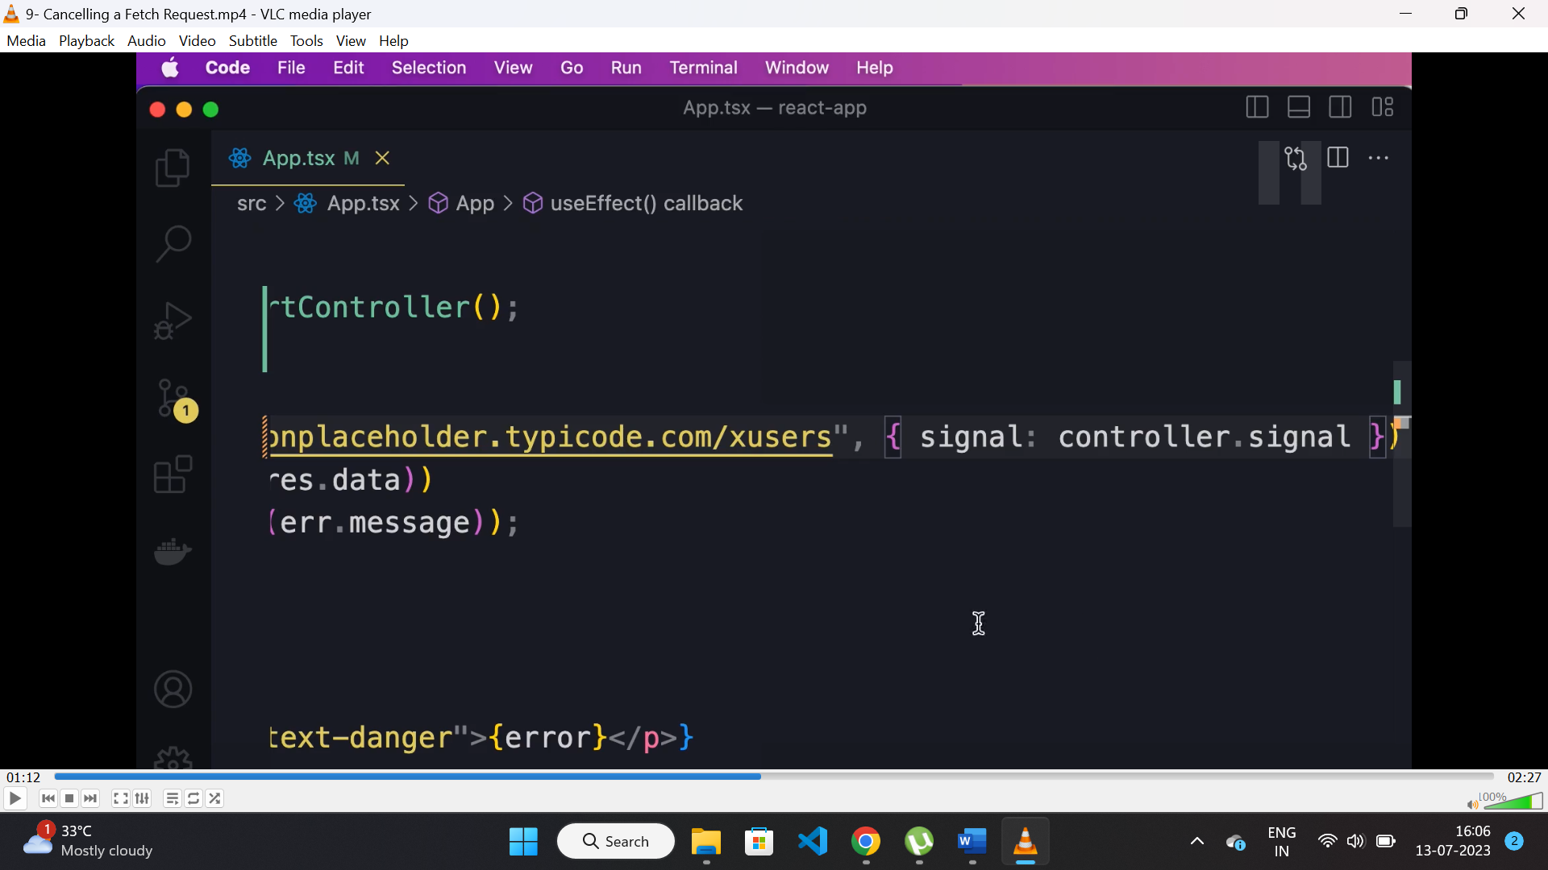

**Axios:**

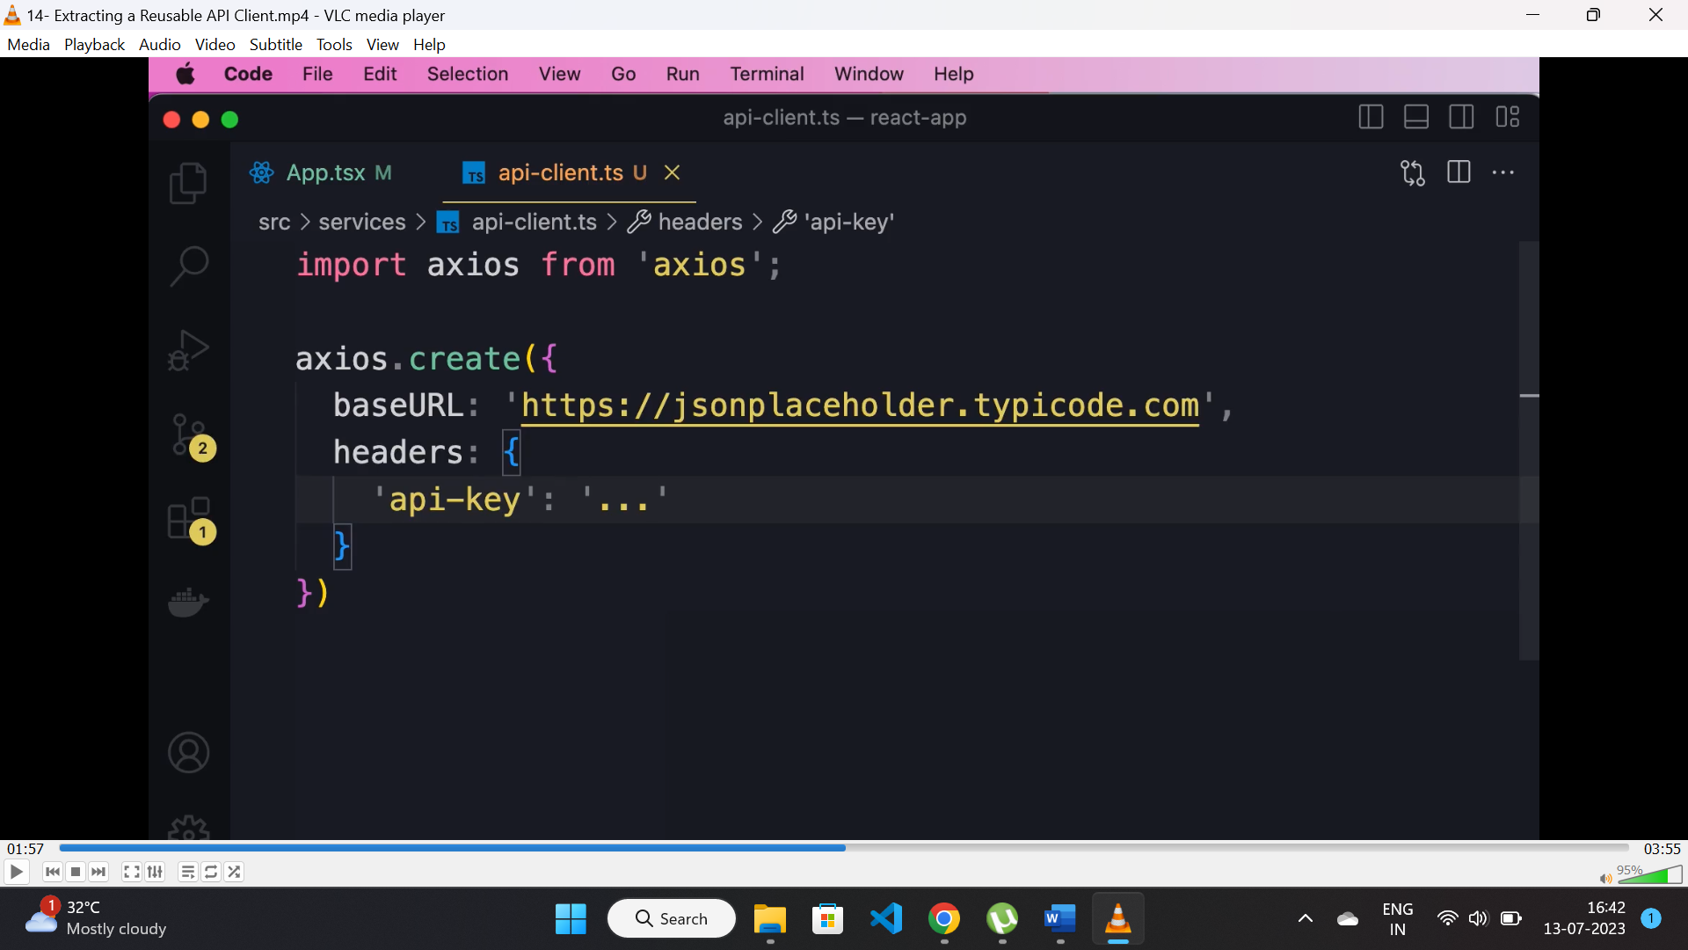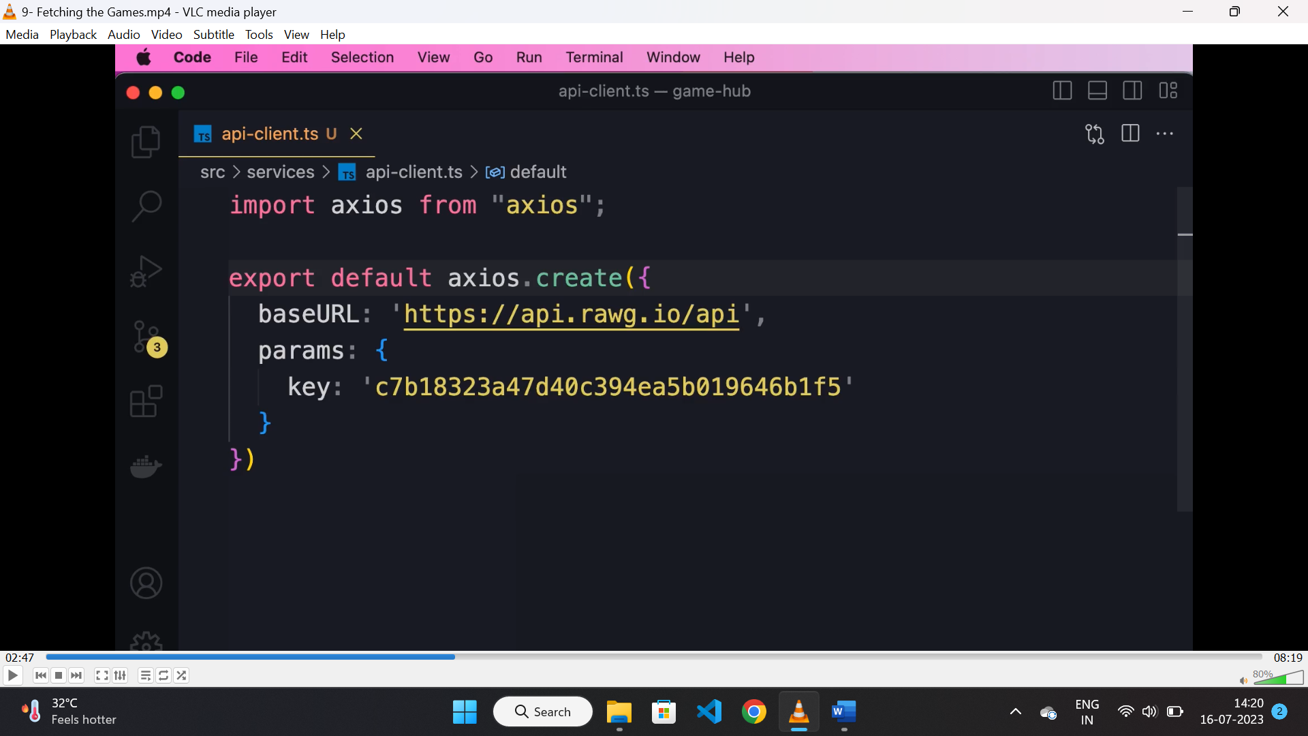

* To create a reusable API client “axios” provides configuration for adding “baseURL” and “header” to be set before being used.

**Extracting service:**

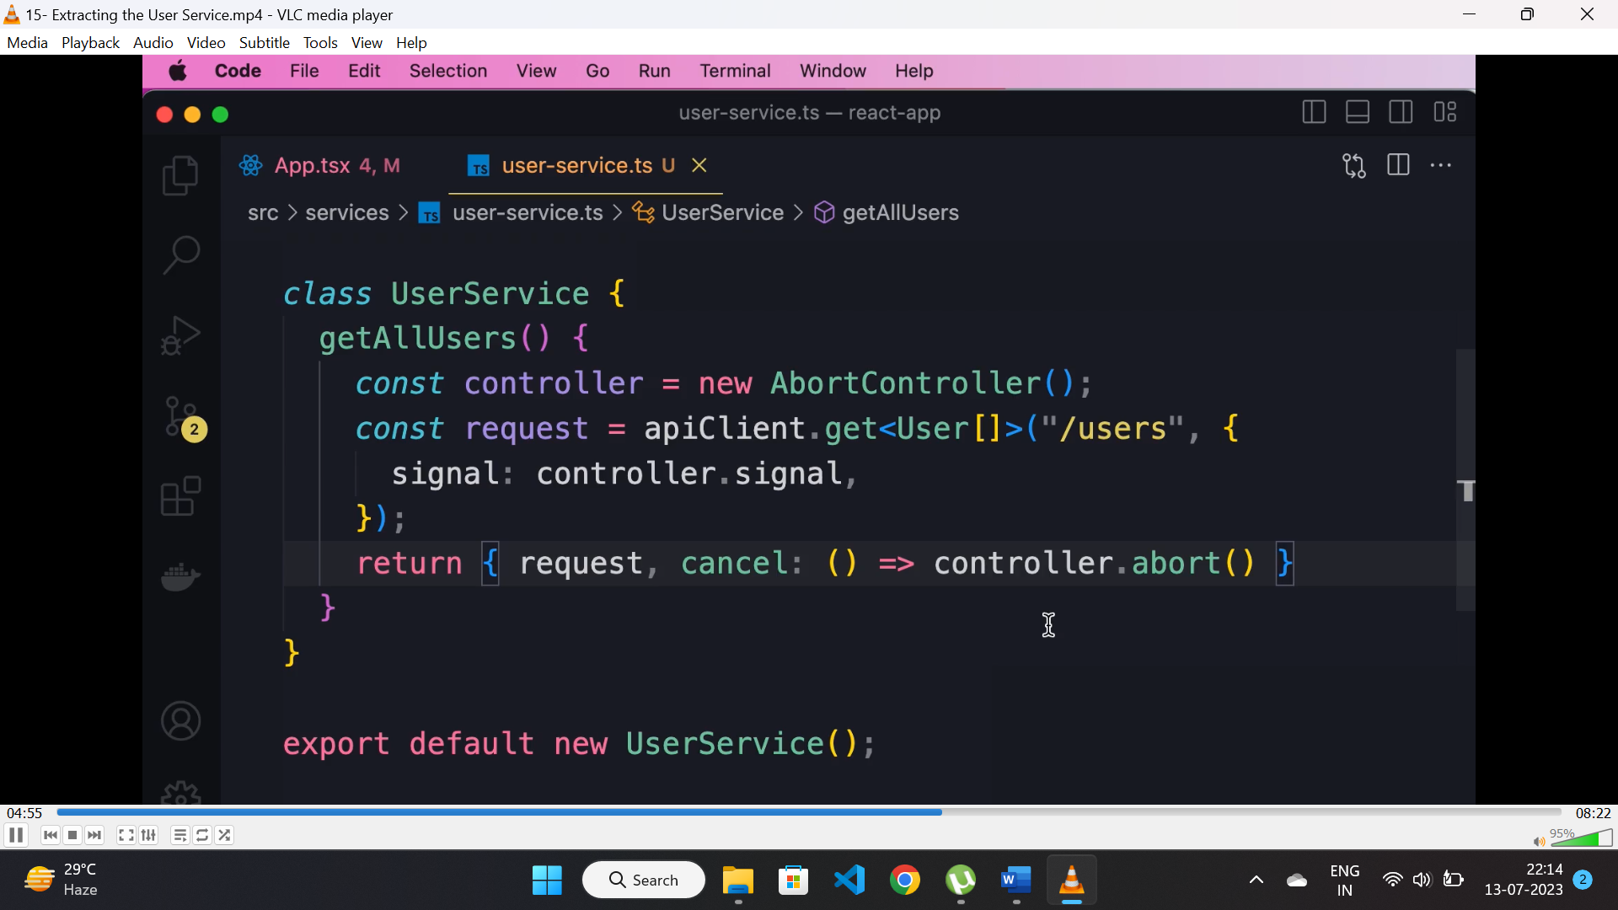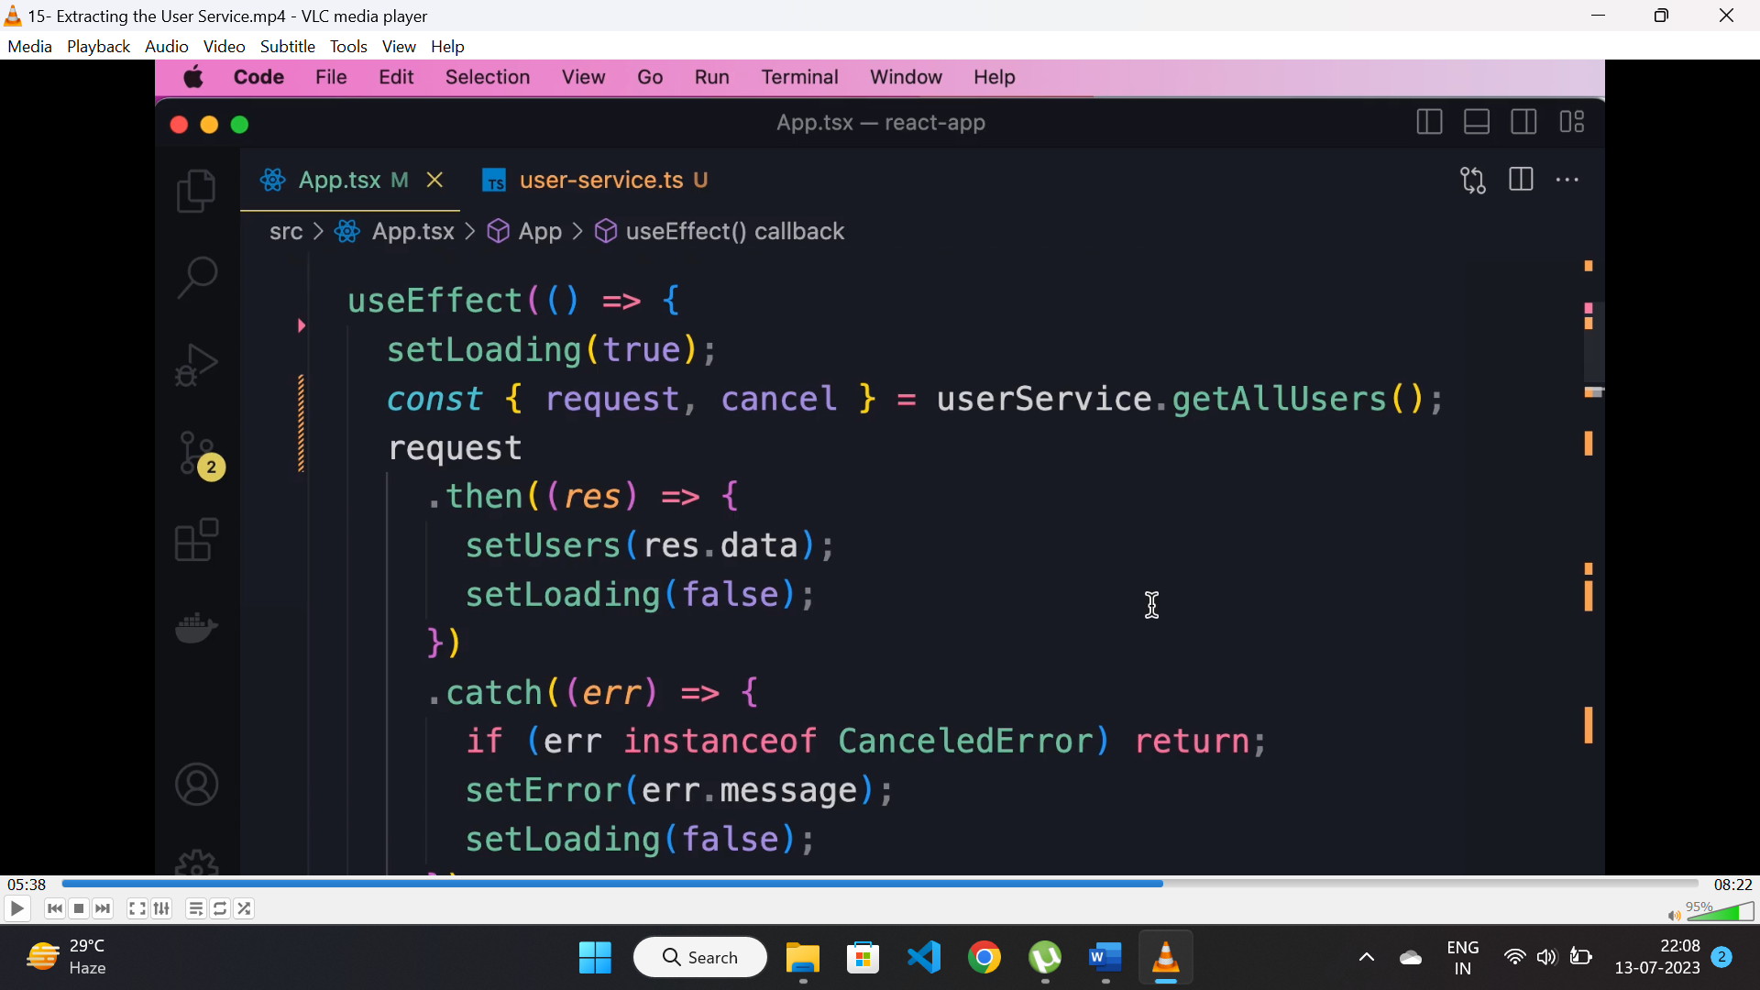

* Instead of calling APIs directly from “useEffect()” hook, we can create a service class for calling APIs and call them whenever it is required to call APIs.

**Generic http service:**

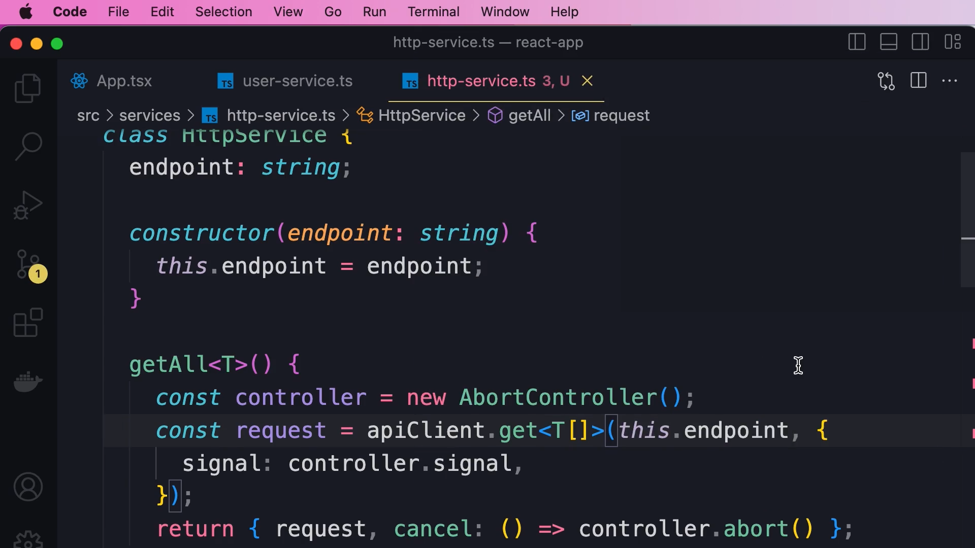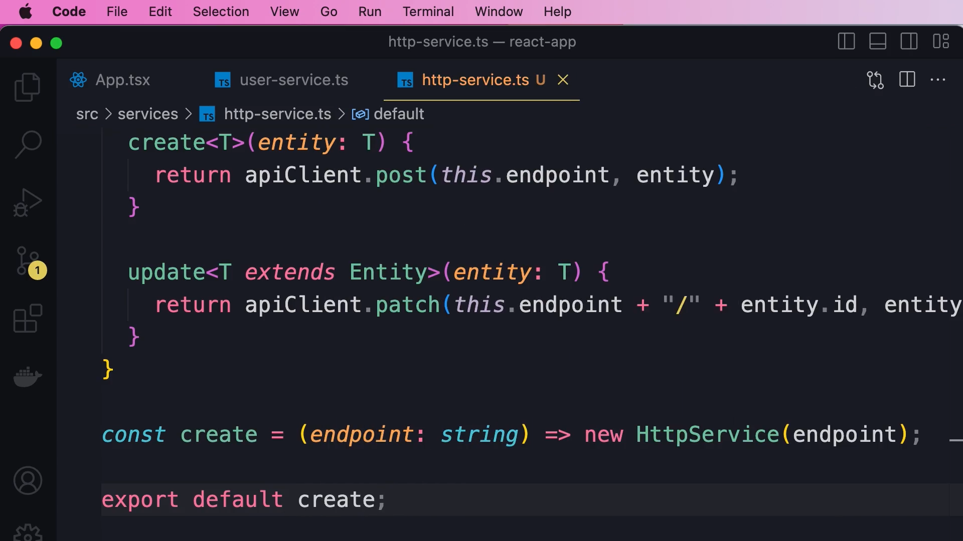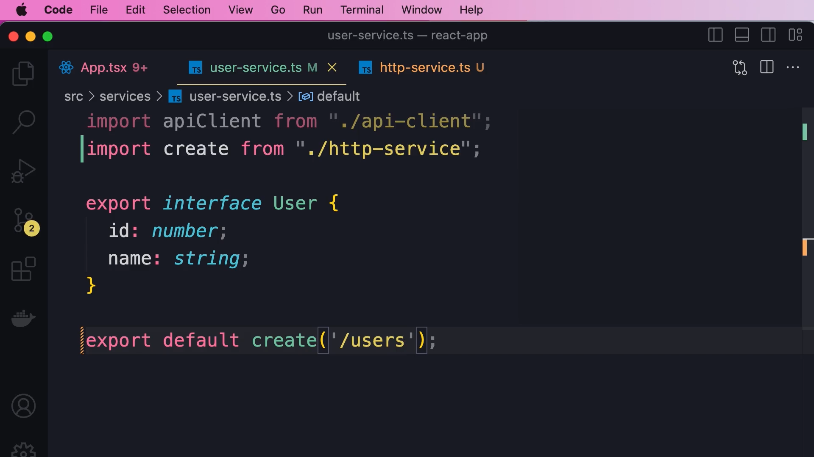

* Instead of calling APIs(services) inside “useEffect()” or any other middleware, we can create a generic service class and define CRUD operations methods inside it.
* Create a constructor for routes.
* Initialize the object of that class with the required route and use its methods.

**Customhook:**

* A “Customhook” is a simple function which we can use for sharing functionalities.
* If we can have repeating code in multiple component, then we can use a “customhook” and add the repeating code within that and use that hook where ever required.